2.

Odisha based NIT Rourkela ranked no 1 among all NITs – By Edurand

19/1/2015

NIT Rourkela is now No.1 among all NITs as per EDU-RAND and 8th among all engineering institutes of India including IITs. Institute has now 275 faculty members(almost with PhD) i.e. highest among all NITs. They have now 5750 students including 850 PhD scholars (almost all doing research inside the campus), in 20 academic departments.

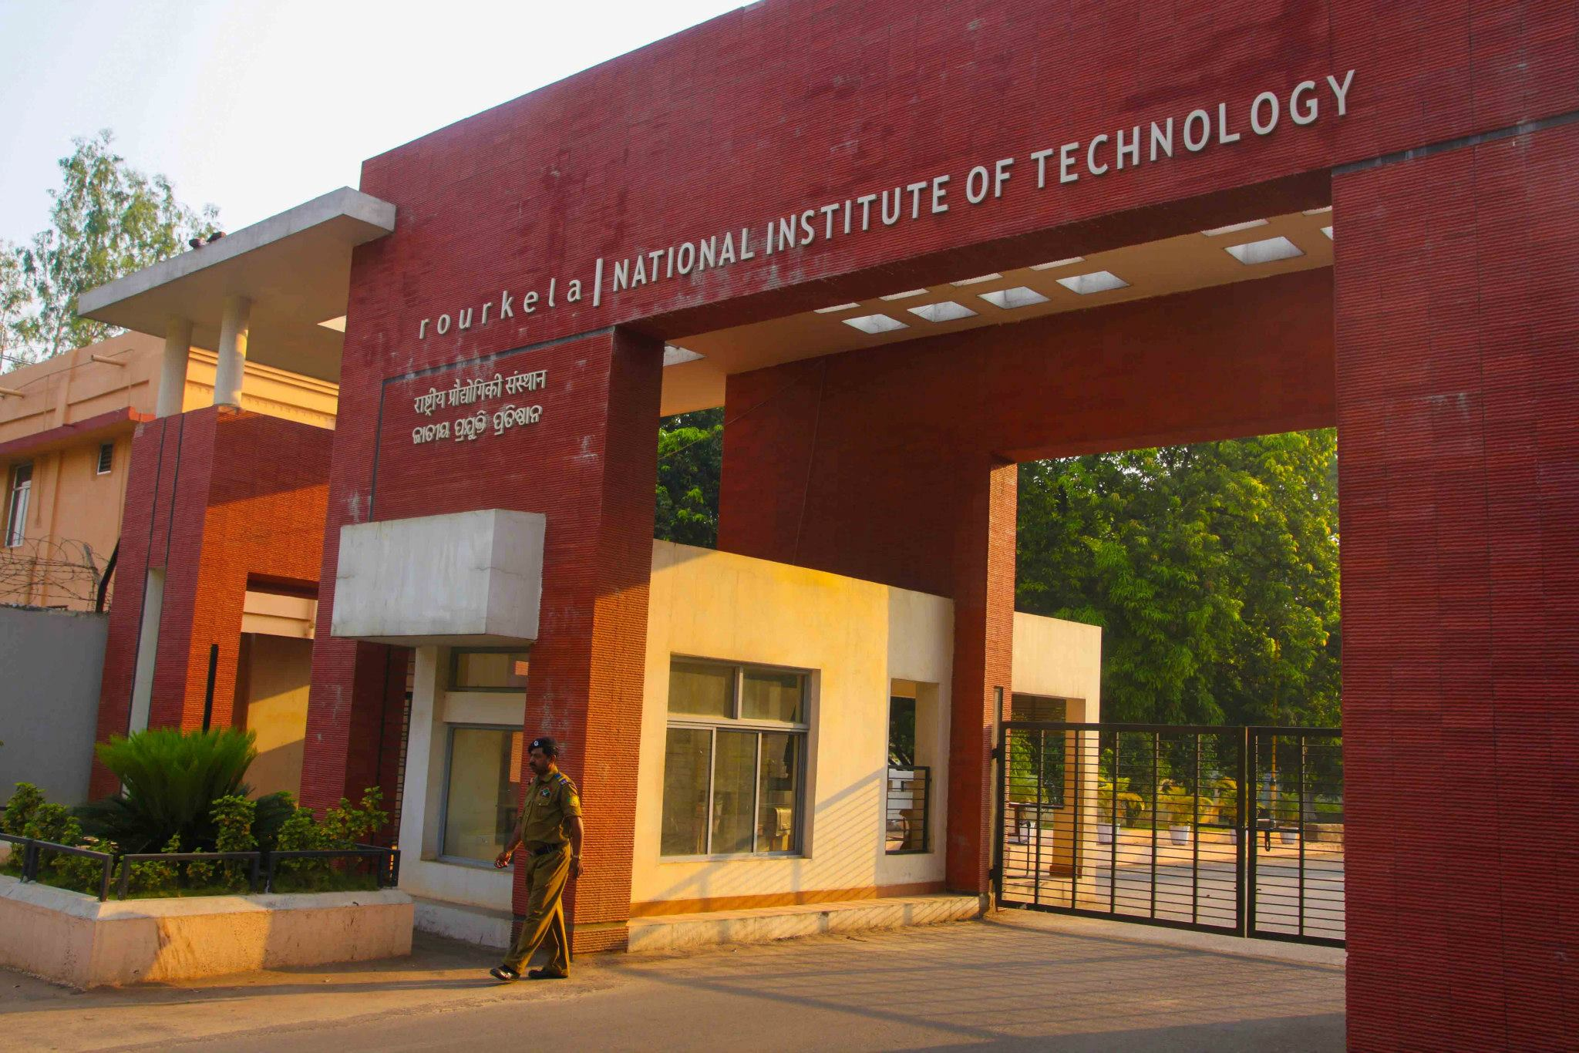

# 3.

# AN EPITOME OF PRAGMATISM: PRIYADARSHI MOHAPATRA

7/11/17

National Institute of Technology, Rourkela hosted the Annual Technical festival from 3rd to 5th November 2017. The three-day long technical carnival, INNOVISION’17 pivoted on the theme of **“Digitalization”** and was conducted by Technical Society, SAC and the euphoric atmosphere reverberated with the slogan, ***“#SIGN_IN_SHINE_OUT”***. NIT Rourkela proudly witnessed Dr. Priyadarshi Mohapatra, the country General Manager at Microsoft India, as the Guest Speaker. He is a 1994 batch alumnus of the Department of Chemical Engineering of NIT Rourkela. Team Monday Morning caught up with the Chief Guest amidst his busy schedule. Here are the excerpts of the candid talk:

**Monday Morning: Tell us something about your days before joining REC.**

**Priyadarshi Mohapatra:** I did my schooling in Kendriya Vidyalaya and then went on to BJB College before joining REC. I was very active in extra-curricular activities during my school days and had represented BJB College in various competitions.

**MM: Why did you choose Chemical Engineering at REC?**

**PM:** The branches were allotted according to the ranks which we have secured in the Entrance exams. At that age, I did not know much about the pros and cons of all the branches. The perspective of Chemical branch seemed good to me as I heard that a lot of people from the branch go to the US and I have always dreamt of going abroad, so I chose it.

**MM:** **Share with us your experiences in the erstwhile REC Rourkela. How important do you think were the four years at REC for your career?**

**PM:** The four years in REC had been a massive learning experience for me. More than the classroom learning, I learned outside the classroom about life, leadership, and organizational skills. **The biggest learning experience which I achieved was the fundamental basics of Organisational skills. I was the Cultural Secretary then and while organizing the Spring Fest I learned a lot about teamwork and managing events successfully.**

I even started a team just like Monday Morning which was known as **Roaming Eye**. Its main focus was to pick up interesting gossips. From that experience, I learned to create a team of members with complementary skills to get optimum output. I would like to mention something from my personal experience:

**Don’t choose people with same skills while building a team, rather look for people with complementary skills and you’ll get sub-optimal output.**

**MM: What made you incline towards pursuing an MBA back in 1995, immediately after graduating from REC as a Chemical Engineer?**

**PM:** There was no plan of mine to pursue MBA in India. During my time, I had topped GRE and I got selected for the top 3 universities. But 15 days before I could leave for the US, my father passed away. It was a turning point for me. I canceled my plan for the US and I stayed back with my mother to support her in business. At that time I realized I have a natural knack for business and I stayed back in Bhubaneswar. I supported my family and did a Management course simultaneously in XIMB. My course of life took an entirely different turn.

**MM: There is a common perception among students nowadays that they need a management degree simply to increase their job packages, but what according to you is the actual need for an MBA?**

**PM:** Doing a course for better salary and job packages is fundamentally a wrong perspective. The foremost thing in life is to pursue a career which interests a person in his/her life. If you want to pursue a career which involves managing a business, running an enterprise or a corporate, and becoming a CEO, then MBA is an extremely important course. MBA is a very well-conceived and well-designed course for an aspirant who wants to pursue a career in the field of Management as it teaches the fundamentals of business.

**MM: How did Oyzter Bay happen? What was the nature of your association with the organization?**

**PM:** I was the co-founder of Oyzter Bay. I started my career in the Management field as a trainee in Titan by selling watches. From Titan, I moved on to Tanishq in 1997. In 2-3 years, we reverted the degressive sales of Tanishq brand into a profitable one. All the 6 of us, the CEO, CFO, the purchase head, the Retail Head and I (who worked as a team in Tanishq) decided to venture out for creating our own company, Oyzter Bay. Our idea was to create precious jewelry for modern contemporary and working women.

**MM: You started with consumer market products and moved to the software market. How different was your experience in it, considering the fact that software was relatively a new concept in the Indian market?**

**PM**: I get where you are going to! This question has been asked to me for multiple times. If at the end of the day you need to understand the business and what your customer actually wants, then it doesn’t really matter what you are selling.  In some cases the customer is an enterprise customer, in others, they are a consumer. But their need and requirements do not change. As long as you relate to the demands of your customer, there is no challenge. When I joined IT industry, I didn’t join as the person who understands technology instead I joined as the person who came for domain expertise and who knew the retail.

**I still remember that in my farewell speech when I was leaving Sun Microsystems and joining SAP labs, Pramanik Bhaskar ( the then VP of Sun Microsystem) said that ‘When I hired this guy he had no idea about technology and even when he is leaving us he still has no idea about of technology.’**

 And when I reflected it again, I realized that I never bothered about technology. But what I bothered was understanding the need of my customers.

**MM:** **How was your overall experience in Sun Microsystems and SAP?**

**PM:** There cannot be many comparisons between both of them. Sun was an infrastructure hardware company, whereas SAP was more of a business application company. My ability to leverage my business knowledge in an application company was far higher than in a hardware company, however, my Sun experience still stands out as one of the best experiences, because that was my first introduction to a technology company where I was challenging myself in a place absolutely alien to me. Also, it was a big risk because I just left my flight which was taking me to one of the best B-Schools in the world. Sun experience was dearer and stayed more than 6 years but SAP gave me an opportunity to leverage my knowledge far better.

**MM: How did Microsoft happen? And how can you describe the work culture at Microsft?**

**PM:**Like I said, part 1 of my life was all about the consumer market, part 2 in my life was all about enterprise and commercial business. And in Microsoft, I saw a unique opportunity of doing a consumer business but what really thrilled me was the fact that consumer business for Microsoft in India was more like a startup opportunity. I was pretty excited and took a plunge because it was more or less like setting up a startup.

The work culture at Microsoft is fabulous. Satya Nadella is an absolutely visionary leader. I would rate him as one of the contemporary leaders not because I am working with Microsoft, but because I am tremendously inspired by him. His biggest contribution for Microsoft is how he changed the culture of the company, how every element has come together to work for the best. The core of Microsoft culture is about “**growth**”, which means a learning mind- symbolizing that at no point in an individual’s life, he can believe that he knows everything. Learning can never be completed, it’s a continuous process.

**I would suggest Satya’s must-read book “HIT REFRESH” for everyone, which has just hit the shelves. It's an inspiring story, where Satya wrote about how he as a CEO influenced the culture at Microsoft.**

**MM: Now that you are visiting REC for the first time after graduation, how important do you think is the alumni-student relationship for an institute like NITR, which is constantly climbing the ladder of rankings?**

**PM:** Fundamentally I don’t believe in rankings, so I won’t comment on that but what I truly believe is in the power of networking. **It's an extremely important tool and it doesn't matter whether you are an educational institute, a professional organization, an enterprise company, a consumer company or an individual, the power of networking works everywhere!** If an educational organization stays connected to its alumni they actually leverage the power of their control. And I am sure that an organization which has a legacy of more than 50 years has lots of its alumni at extremely senior positions across the world and the institute should capitalise on it.

**MM: How do you keep your spirits high amidst professional pressure and hectic schedule?**

**PM:** To be a cooperate athlete, you actually need to draw an analogy of being a physical athlete. If you have to win the competition you have to constantly build your stamina, stay physically and mentally fit, set your benchmark and then only laurels can be brought on the performance day.  
Corporate leaders need to bring clarity, bring energy to the organization and deliver services. I don’t think I practice being energetic or motivational because I believe that as a leader you can’t have a bad day, you should always have a good day!

**MM: Any message that you would like to leave for our readers:**

**PM: Enjoy your present moment, don’t think that you’ll get lost, or be confused, rather stay in the present moment and enjoy what you’re doing. Once you start enjoying, you’ll realize what is your strength and can pursue your passion. When you are through this journey, tell yourself every moment that each experience will teach you something. Learn and keep moving, always!**

* 4.

# **World University Rankings 2018 by subject: engineering and technology**

Dear All,

We would like to share another good news related to our Institute. NIT Rourkela has been placed within 401-500 in Times world university rankings for higher education under "Engineering and Technology" category. This year, such category has been created for the first time by them. Among Indian institutions under this category, NIT Rourkela has secured 10th place. Moreover, NIT Rourkela is the only NIT, that has secured a place in this list. For details, please see the link:

[https://www.timeshighereducation.com/…/…/engineering-and-IT…](https://www.timeshighereducation.com/world-university-rankings/2018/subject-ranking/engineering-and-IT#!/page/0/length/25/locations/IN/sort_by/rank/sort_order/asc/cols/stats)

Also other category rankings are shared here.

NITRAA Social Media

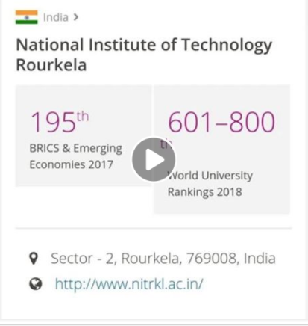

5.

NITRAA BENGALURU CHAPTER FRESHER’S

12/SEPT/2017

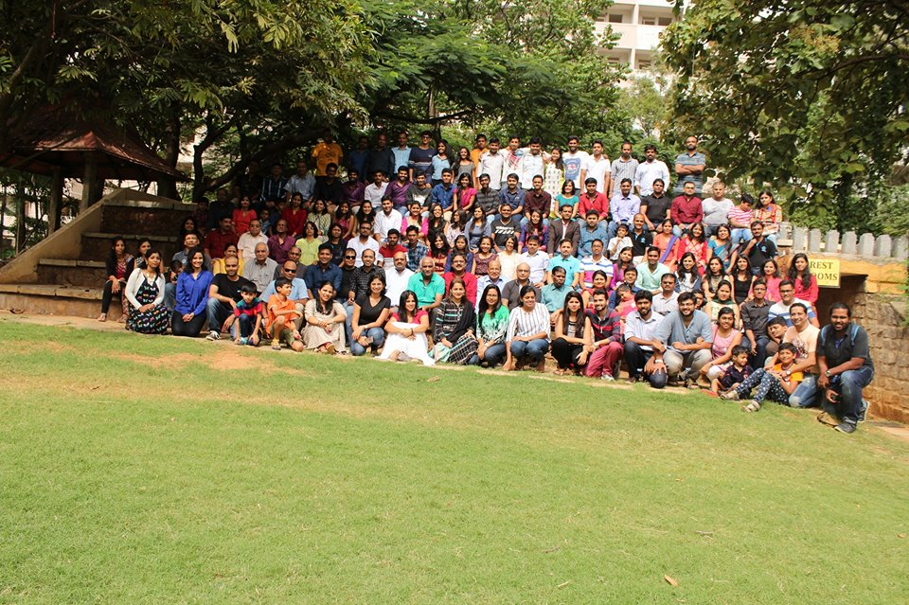

NITRAA Bengaluru welcomes its fresher’s at Silicon Valley in style.

As part of on-going activities of the central NITRAA, NITRAA Bengaluru chapter organized a fresher’s welcome meet along with get together of all the Alumni members and families. The meet was organized at nearby resort Manipal County on 06th August 2017, attended by around 60 students from fresh batches (2016 & 2017 batches) and 150 alumni from the city. It could attract alumni from as old as the 1965 batch of NITR (the then REC, Rourkela) to the fresher’s of 2017 batch attending the soiree. The meet was attended by many dignitaries from academic as well as industries and notables.   
The meet started with a welcome address by Mr. Khandanga, Chairman NITRAA Bengaluru Chapter, welcoming the group and followed by short address on the overview of day’s agenda by Mr. Tara Mahapatra. Post that, Padma Shri N.R Mohanty (Ex-Chairman, HAL, Bengaluru) was invited to address the gathering and all the members of the freshly joined batch were inducted to the chapter officially with a fantastic video presentation and ramp up to stage. NITRAA Bengaluru secretary Mrs. Arati Nanda and core members shared their vision for the chapter growth to the audience and gathered new suggestion to improve upon the activities of the association. NITRAA Bengaluru chapter fully recognizes the importance of its role in strengthening the placement records to NITR. The current placement Prof. S.K. Patel shared the message and best wishes on behalf of Institute and appealed to all the entire NITRAA community for their active help to bringing in more companies to campuses. NITRAA Central President Mr. Venkata Narasimham Peri addressed the gathering over video conferencing by sharing his thoughts and vision regarding the overall functioning of NITRAA, its global presence and relevance in strengthening the brand NITR.   
Crowd was cheered on another video presentation edited and directed by Cinematics club was on display primarily describing on history of NITR starting from REC days. The highlight of event was the launch of PANNIT mobile app on exclusively for NITRAA members across the chapters. This app is planned to be rolled out to other chapters during their annual meeting and NITRAA members were requested to leverage this platform for group interactions. The morning session of meet ended with open house discussion wherein NITRAA Bengaluru core office bearers taking feedback and suggestions from members present and the queries of the house were addressed by the NITRAA core office bearers followed by lunch.  
The group interacted well with during the lunch and gathered back for the cultural performances from Alumni and fresher’s batch. A session on topic “Start-up ecosystem” by Ms. Sangeeta gained wide attention in gathering, especially with city being known for its vibrant start-up culture.   
NITRAA Bengaluru Chapter plans to host many more such meets in future to bring alumnus across the globe together in a common platform to interact with each other and strengthen alumni relations. We also express our gratitude to our sponsors, Adobe, Total Environment, Trident Hyundai and Proman Infra for their support and encouragement.

NITRAA Social Media

6.

# TIIR: WHERE IDEAS GET WINGS!

31/8/17

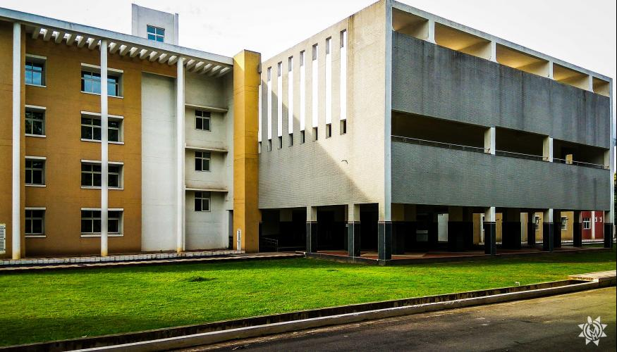

**Technology Innovation and Industry Relations (TIIR)** building, located in the north-eastern corner of the academic campus is now operating in full swing after a wait of many long years. The motive behind its inception is to provide facilities for translation of scientific ideas to practical services, by allowing students to carry out their R&D, product development, limited production, labeling, and marketing from the allotted space.

TIIR building encompasses the following eight units which include:

* Technology Incubation Cell (TIC)
* Business Incubation Cell (BIC)
* Skill Enhancement Cell (SEC)
* Training & Placement Cell (TPC)
* Intellectual Property Cell (IPC)
* Facilities and Support System (FSS)
* Common Design Unit (CDU)
* Common Fabrication Unit (CFU)

Currently, the **Training & Placement Cell** (ground floor), **Start-up & Incubation Centre** (1st floor) and the recently shifted Department of Planning and Architecture (2nd floor) are housed inside the TIIR building. The construction of the TIIR building began in May 2012 and has been completed recently.

**INFRASTRUCTURE:**

This three-storey building provides a floor space of around 10,000 m2 and is definitely a state-of-art infrastructure on the campus, with expansive AC installed rooms in most of the units. In spite of the building having adequate facilities, several glitches are brought to notice for further improvement, noting a few:

* **Power Backup-** Only the ground floor and basement enjoy the privilege of power backup, that also at most for an hour. With the TIIR building housing, the essentials of NITR; power backup of efficient grade should be installed for the entire building so as to ensure power supply for a longer duration.

* **Elevators/Lifts-** With the building being a prime significance to the institute, lack of elevators inside it creates a major problem for many people; especially for the physically disabled students.

**Prof. S.S Mohapatra, Head of TIIR**says,

**It is a matter of paramount importance and the proposal of introducing lifts has already been put up and the changes might be seen within a year.**

**DEPARTMENT OF PLANNING AND ARCHITECTURE:**

With the commencement of the new academic session, the **Department of Planning & Architecture** shifted from the old building (beside the Central Library) to the recently furnished TIIR building. The Department is in good spirits with the classrooms becoming more spacious and ventilated. It flaunts a library of its own, although they are yet to recover from the absence of a librarian. Nevertheless, the faculty, as well as students, are contented with the changes made for the good.

**START-UPS:**

In this era of entrepreneurship and start-ups, TIIR is playing the role of a mother for entrepreneurs and lays a strong foundation for the kid in the early stages of life. The TIIR is the hub of business incubation, and technology and has been extremely helpful in providing numerous facilities to the young entrepreneurs of the Institute and some of these include:

* Mentorship from experienced professors.
* Rent free office space.
* Free electricity and water supply.
* Start-up sessions and meetings organized by TIIR.
* Free passes to various start-up summits.
* 24*7 internet connectivity.

As a result of the firm support that the TIIR provides, many start-ups have been registered under the TIIR which have been listed as follows:

* AWALK- Creating Innovation
* BookFount
* Dovel Solutions Private Limited
* Estinno (Eastern Innovation)
* Grabbucks Internet Private Limited
* Honorarium Online Services
* Hostelcart.com
* Ikshate Technologies
* M/s See Green Technologies
* Merferry Technologies
* Minz Chemicals Private Limited
* Ovotees, Fastech Fashions Private Ltd.
* Phoenix Robotix
* Poly Refractories Private Ltd.
* S-Mudra Finances
* Srinivasa Lunch Room(SLR)
* Techpros Online Services LLP
* Trinit Cryo Technology Private Ltd.
* Watchers
* Corasia Technologies
* Shiva Jyoti Fuels and Chemicals
* Digiketing Software Consulting Pvt. Ltd.

**Abhijeet Sahoo, CEO, Ovotees** says,

**TIIR has provided tremendous support to us. Without the help of Prof. B.B Biswal, Prof Rajiv Kumar Panda and Prof. S.S Mohapatra, we couldn’t have attained a name in the start-up culture. The credit goes to them for helping us in not just becoming the youngest start-up of the State, but also being the first one to be recognised by Government of Odisha.**

In spite of the fact that TIIR is quite supportive and trying its best to promote the start-up culture, certain aspects that need to be addressed are:

* **Sanctioning of Leaves**: Students get a good amount of invitations via TIIR to attend start-up summits, meetings, and mentoring sessions, but it is infeasible to attend those seminars owing to the cumbersome process of sanctioning leaves for the same. Team MM brought this issue to the notice of Prof. S.S. Mohapatra, who assured that if the conferences are indeed related to the students’ respective start-ups and business incubation, they shall definitely be granted leaves to attend the same. Furthermore, he will discuss with the Dean (Academics) and Director to simplify the process of obtaining leaves.

* **Procedure for Getting registered under TIIR:** The present procedure of getting recognition from TIIR involves submitting an application detailing the idea about the product/service following which patent rights should be obtained for the product/service. Based on the application received the start-up is recognized by TIIR. However, TIIR is planning to digitize the entire process which will not only be an efficient way of registration but also provide an efficient platform for all the interested innovators to develop and grow. Prof. Mohapatra informed MM that a meeting was held on 16th August 2017 to frame a well-structured constitution of TIIR, which was supposed to be finalized by 24th of this month.

* **Fabrication Centre:** TIIR is going to install fabrication units such as Computer Numerical Control machines and Rapid Prototyping machines in the basement of the building.

* ​​​​​**Technical Assistants:** With more and more machines coming into the picture, the need for technical assistance is definitely high. TIIR already has three technical assistants ready to cater to the needs of the students and the faculties. Hence, the available manpower and machines must be efficiently utilized to make the start-up culture of NIT Rourkela reach greater heights.

* **Generation of funds:** Few other counterparts like **IIT Kanpur, IIT Bombay, IIT Kharagpur** and even private universities like **KIIT, Bhubaneshwar** have an intensively developed incubation center; hence their start-ups are gaining worldwide recognition. Their achievements have only been possible because of the huge funding that is allotted to them. However, this is not the case with NIT Rourkela. Start-up culture here is still in its infancy and undoubtedly needs awareness, recognition, and funds.

Professor S.S. Mohapatra, Head of TIIR further informs that he has been writing to several authorities since past few months to generate funds for incubating start-ups. Accordingly, they have received a grant of 5 crores INR to form a section-8 company (no loss, no profit company) which shall be the foundation for all technical and business incubation. **Department of Planning and Convergence, Government of Odisha and NITI Aayog are planning to fund 1 crore INR and 5 crores INR respectively**for bolstering the activities at TIIR**.**It is expected that funds amounting to about **INR 20 crores**will be raised by the end of this year**.**

Professor S.S. Mohapatra, Head of TIIR exclaimed:

**We have a lot of opportunities. A lot has been done; though a lot more needs to be done! Rourkela is basically a tribal area and we have a lot of scope in small scale industries like low-cost housing and rain water harvesting. The students from all departments like Mechanical, Food Processing, Metallurgical and Material Science can collaborate and create wonders! All they need is guidance, creative ideas and a zeal to innovate!**

**TRAINING AND PLACEMENT CELL:**

The Training and Placement Cell, which was earlier operating in PPA has also moved into TIIR building. The Online tests, Group Discussions, and Interviews are taking place at TIIR, but sometimes Computer Centre at LA-1 is also booked because the one in TIIR can accommodate a maximum of 200 students only.

The major issue that surfaced in TIIR was the absence of Air Conditioners, ventilation and an audio system in the main auditorium. On enquiring about the same with Prof. S.S. Mohanty, he informed Team MM that a budget amounting to 70 lakh INR has been approved by the Finance Committee for the installation of Central Air Conditioning system in the auditorium as well as in the Computer Centre at LA. Further proposals include setting up of a **Round Table Conference Hall** in TIIR building, with all facilities like audio system, projector, and air conditioning, especially to cater for the BOG Meetings. In addition, this conference hall will be used for the executive meetings during the MDP/FDP and other industry oriented programs.

TIIR is not merely a building, but the cradle of ideas, imagination, and innovation. Monday Morning gave you the sneak peek of its current status and now, it’s your turn to dive into the ocean of opportunities.Team MM wishes luck to the upcoming start-ups and hopes for a successful placement session of the NITR junta!

7.

Illustrious and inspiring N.R Mohanty

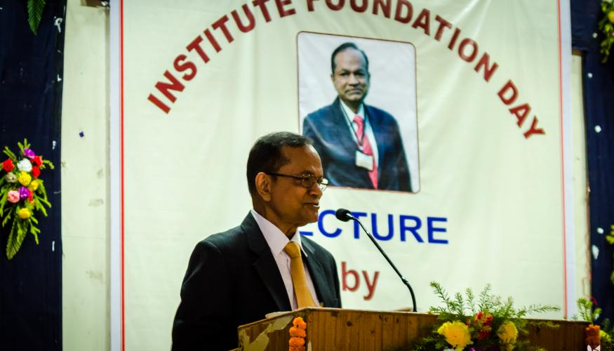

21/8/17

**Padma Shri Nalini Ranjan Mohanty** is an alumnus from the first batch of REC, 1965 and is a well-known figure in the aviation industry of the nation. He had an illustrious career spanning 31 years with Hindustan Aeronautics Limited (HAL), where he rose up to the rank of CEO of the organization. He has also contributed significantly with his expertise to the AeronauticalSociety of India (ASI) and Textron (India). Recently, on a visit to NITR for the Foundation Day celebrations, Team MM caught up with this magnanimous personality for a little tete-e-tete. Here are a few excerpts from the interview.

**MM: Tell us something about your days before REC.**

**NRM**: I had a very enjoyable childhood. I was the oldest child of my family and was pampered by every other member. My father had an administrative job, so we had to move along with him whenever he was transferred to a new city. I was good at studies and was applauded by my teachers and friends alike. By the time I completed my schooling, I had studied in six different schools, which in hindsight feels like a boon.

After my schooling, I joined **Ravenshaw** College, which was one of the premier colleges of Odisha back then. I was residing in my college hostel. Ravenshaw had excellent infrastructure, a huge library and highly experienced professors. Besides that, my classmates were of very high caliber and the environment was very competitive. It was then, when I was in Ravenshaw that I dreamt of joining a reputed college of India and grow up as an engineer.

**MM**: **How important do you think were the years at REC for your career? Considering the fact that you were the first batch to graduate, how would you describe your experience at REC?**

**NRM**: It was nothing less than a miracle that REC happened in my life. Probably, I would have never become an engineer, had it not been the establishment of the college in the year 1961. This story is quite long. I was not meeting the minimum age limit for admission into IITs, thus preventing me from appearing for the IIT Entrance Exam. I was totally dejected and frustrated when I witnessed my friends with lower marks getting admission in BHU (Banaras Hindi University). I continued my studies in Ravenshaw and pursued B.Sc. in Mathematics (Honors). On the independence day of 1961, Biju Pattnaik, the legendary leader and the greatest statesman from Odisha declared the establishment of REC, Rourkela and I became one of the luckiest students to get admitted into this institute.

As a new college, it hardly had any infrastructure of its own. It started from an ITI at Panposh and we continued there for a year before moving out. But the real strength of the institute lied with the founder, **Principal, Prof. Bhubaneswar Behera** and the experienced faculty members, who were selected from reputed colleges from all over the country. They displayed incredible devotion in building this institute from scratch. We were the 120 lucky students of the 1st batch, and were privileged enough to receive special coaching and personal attention from the faculties.

**MM**: **After graduating, you joined REC as a faculty member. How would you describe the transition from a student to a faculty?**

**NRM:**It was not just the transition from a student to a faculty member, but also the beginning of my professional career. It was a highly inspirational beginning. I was loved and blessed by my own teachers and respected by students. It was an exciting experience and I always tried to be a student-friendly teacher.

**MM**: **You later joined the Indian Ordnance Factories Service and worked with the major ordnance manufacturing industries of the country. How would you describe your experience in the ordnance industry?**

**NRM:** I joined **Indian Ordnance Factories Service** in December 1966. I worked at **Gun Carriage Factory, Jabalpur and Heavy Vehicles Factory (Tank Factory) at Avadi, Madras** till June 1971. These are well-developed defense factories which were established during the British Raj. It was my first experience in the industry where I got to learn a lot of things through my experience and the opportunity to acquaint myself with manufacturing technologies and planning processes. It was an excellent platform to learn and specialize in **Finance and Human Resource Management**.

**MM:** **You later joined HAL and were associated with HAL for the next few decades. How did HAL happen and what spiked your interest in the Aeronautical Industry?**

**NRM**: I have served at **HAL** for more than 33 years in various capacities and finally became its Chief Executive Officer. It is a great organization, a technological paradise for any stream of engineering. It provides opportunities and freedom to learn, experiment and implement the knowledge acquired through books. It imbibes high standard of personal values such as integrity, credibility and fair play, which are necessary for working in such an organization. I grew up in this organization, made significant contributions and was suitably rewarded.

**My contributions to HAL were well recognized by a Fortune 500 US Company named TEXTRON and they chose me as the CMD of Textron (India) for 6 years. Even today, Govt. of India has engaged me in various important Defence Committees and I continue to be an Independent Director on Boards of many companies.**

**MM: How would you describe HAL’s evolution from 1971 to 2001? How would you describe the impact of HAL on augmenting the Indian Aero Defense systems?**

**NRM**: During this period, HAL made significant contributions to the field of Aerospace Engineering. HAL had an extremely qualified design team. The task was to engage the team by assigning them a challenge so that they can contribute to HAL. Prior to this period, the defense forces had ordered for a number of aircraft and helicopters, but the delivery wasn't completed by HAL, much to the dismay of the defense forces. I landed myself in the helicopter division in September 2001.

My target was to satisfy the customers before 31st March 2002. I formed a new team and was determined to contribute in anyway they wanted. I used to make the occasional surprise visits to the workshop floor. My objective was to encourage and motivate the team to work and design the helicopters. By the end of March, we produced seven helicopters. More than a decade had passed without the production of even one helicopter, so you can imagine the transformation which was underway. The following two years, three and fourteen helicopters were produced respectively.

Today, HAL has established itself as an internationally recognized brand in the aviation industry with an overhaul of aircraft, helicopters, aero-engines and much more. There are huge requirements of aircraft and helicopters both for military and civil sectors in our country. Strategic partnerships should be taken up, especially with private-sector companies to help expand the aeronautical industry in India.

**MM**: **You also served as a non-executive Director in major public sector undertakings such as Kudremukh Iron Ore Company, Mahanadi Coalfields, Dynamatic Technologies to name a few. How would you describe your experience in the public sector industries?**

**NRM**: I think the experience of serving as an Independent Director in both PSUs and Private Sector Undertakings have been very positive. The deliberations in the Boards are quite open and transparent. It has helped me a lot to understand the functioning of companies.

**MM:** **Having been a member of the Kelkar Committee, what are your views on private-sector participation in the defense industry and how do you think it can boost India’s defensive prowess?**

**NRM:**The Central Government has been planning to include and augment private sector participation in Defence Production for many years. The present Government has approved the model of selecting **Strategic Partners** from Private Industries for Defence Production. The private companies will be working in the segments of aircraft, helicopters, submarines and armed vehicles. The total order value will be 2 lakh crores of rupees.

**As a consequence of the participation of private companies, a large amount of FDI will flow into our country. A strong industrial ecosystem will be created as a result of the Make in India Programme, which will result in large-scale employment generation. When we talk about the private sector joining the defense industry, we are not talking about shutting the public sector out. This will actually provide healthy competition; both the sectors will grow simultaneously. The private sector alone cannot build an aircraft; they’ll struggle for years and they will take time to master the technology. So, both the private and the public sectors should join hands and pool resources.**

**MM:** **You have received numerous honors and awards throughout your lifetime. Which one would you rate as your most coveted achievement?**

**NRM:** Out of all the honors bestowed on me, I feel the **Padma Shri** is the most special achievement.

**MM**: **You visited the Institute after a long time and recently you have been inducted as a member of the BOG, how do you look forward to it?**

**NRM:** Our Institute has grown significantly. It presents a scholastic atmosphere. Truly, it has become an institute of national importance. I consider myself privileged to be a member of the BOG of my Alma Mater. I shall strive along with the Chairman and other distinguished members of the Board to enhance the brand image of our Institute.

**I look forward to the feedback of students to know what changes are required. I will consider their demands and would try to fulfill them.**

**MM**: **What is your take on the role of alumni for an institute of national importance like ours? How do you think the present scenario of alumni interaction can be improved?**

**NRM**: Alumni play a vital role in shaping an institute. They should contribute both physically and financially to create a world-class institute. A sense of trust needs to be established between the Alumni Association and the institute. The newly appointed Director and the NITRAA President have taken numerous steps to ensure that the level of interaction improves and I hope that a positive change will be seen in the future.

​​​​**MM:** **How do you keep your spirits high amidst professional pressure and hectic schedule? Any long drawn hobbies that you still indulge in?**

**NRM**: I regularly indulge in my prayers for strength and wisdom, particularly during the hours of trouble. I used to play bridge. I started playing the game in the Faculties’ club at REC (NITR). In addition to this, I’m very fond of cricket. I didn’t play much but when I was in college, my batch mates used to choose me as the non-playing captain of the team. Today, after retirement, I still work on various boards, I am a consultant to two major companies and that keeps me busy.

**MM:** **You have come a long way in your journey; how do you feel when you look back – do you have any regrets?**

**NRM**: I don’t have any regrets so far. Maybe, it is because of the karma of my parents and the blessings of the supreme power that I have had my fair share of ups and downs. That invisible power had always guided me during my period of distress. For instance, once I couldn’t get the position of the Managing Director of HAL and was disappointed; but then I became the chairman of the company owing to my dedication and hard work. Something propelled me to do my job after failing to become the MD of HAL. One needs to work hard and should have faith in the almighty.

**MM:** **What does it take to be Nalini Ranjan Mohanty? Please enlighten our readers with a few lines of inspiration.**

**NRM:** I sincerely pray that every reader should be able to beat me at each and every step of his or her life’s journey. Students should know their interests and set goals accordingly. They should work hard to achieve their goals. They should never believe that they are over-ambitious. My life’s mantra is:

**Fewer excuses, bigger results; fewer distractions, more focus.**

And I want the students to follow this so that they can achieve something bigger in their life.

8.

# THE ELECTRONICS VIRTUOSO: SARAT KUMAR PATRA

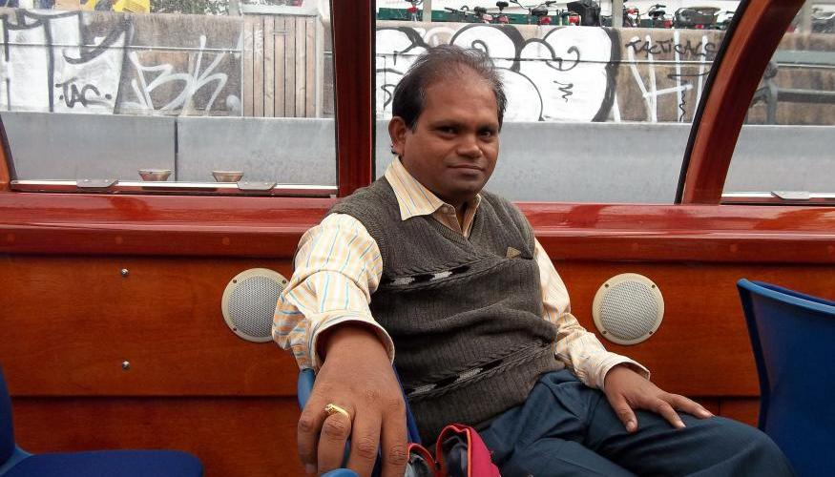

9/8/17

A calm and amicable person, Professor **Sarat Kumar Patra** of the **Department of Electronics and Communication Engineering** has been recently appointed as the Director of IIIT, Vadodara. In his 28-long career at NIT, Rourkela, he has handled several crucial responsibilities including Dean (Faculty Welfare) and the HOD of the Computer Centre. Read on to gain insight about his eventful journey.

**MM: Tell us about your childhood days, the days that you spent at Sainik School:**

**SKP:**I was born and bought up at **Rourkela**. At the age of ten, I joined Sainik School, Bhubaneswar. At that time, English medium education was very expensive and a middle class family could not afford to send their children to such schools. On the other hand, Sainik School provided the ambience and facilities of an English Medium school at a very low cost. I was one of the hundred students from Odisha who got selected for admission into Sainik school. In Sainik school, we led a disciplined life and learnt to live in a hostel since the age of ten. We became independent as we had to do our daily chorus ourselves. My stay at Sainik School helped me in imbibing attributes like **confidence** and **time management, which helped me to stick to my principles throughout my career**.

**MM: How did Electronics and Communication Engineering happen to you? Was it your choice or fate had it in store for you?**

**SKP:** I would say it was a matter of chance, I did my engineering in 1982 and people then were unaware of the existence of a Branch called Electronics. I went alone for counseling which was held at Bhubaneswar, because my father had some health issues. There were two options available for me, either to choose a REC or to go for electronics at Burla, I chose the latter and my B.Tech journey began. I took my own time to get accustomed to the the timetable of VSSUT because the time slots varied largely when comapred with Sainik school. Even the academic calendar was not streamlined, owing to which the university exams were very unpredictable; however the scenario is much different now a days. The academic schedule was very lenient; there used to be a gap of two days between exams followed by external evaluation. The labs were very strict which required us to submit our records within 48 hours. Though I joined this branch without any prior knowledge but eventually I grasped it’s essence and had a pleasurable learning experience at VSSUT, Burla.

**MM: What differences do you observe when you compare engineering students then to those now?**

**SKP:**Now a days children **are much smarter.** With time, intelligence quotient has changed, as a result of the changing nutrition levels and education system. During our times, we witnessed that engineers lead a superior life compared to others. Hence, we took up engineering. But in the present scenario children are **much more knowledgeable** and they do a fair amount of research before choosing any particular college (or) branch.

**MM: How was your experience at DRDO, Chandipur?**

**SKP:** I was a part of the team that built a lab at DRDO, Chandipur. Though we were at the bottom of the executive level, yet I managed to learn many new things. It gave me good exposure and I came to know of the constraints required for building a research lab. We figured out several loop holes in the industrial mechanism. The first Agni missile was tested on May, 1989 from DRDO, Chandipur and I left the organisation after two months. Although I could not spend a lot of time at DRDO due to some compelling reasons, but I learnt a lot from the scientists working in the organization.

**MM: When did you join NITR and how has the journey been since then?**

**SKP:**After DRDO, I joined NITR as a faculty member. After joining, I realized that an M.Tech degree was a must and thus completed my M.Tech at NITR. Later I discovered that PhD is the minimum requirement for excelling in a teaching career and thus did my PhD. My M.Tech. days were very uncertain because then REC was under **Sambalpur university**, there were large gaps between the semester examinations. There weren’t any specific deadlines for project evaluation and thesis submission, which made it very tough for us.

**MM: What differences do you observe on comparing REC, Rourkela of 1989 with NIT, Rourkela of 2017?**

**SKP:**During our time, a B.Tech. graduate was considered good enough to become a lecturer. But the current scenario is quite different and having a PhD degree is considered mandatory to get recruited as an Assistant Professor. Also, now a days, teaching B.Tech. students is only a subset of a Professor’s job. Their job also includes teaching M.Tech. students, guiding PhD scholars, supervising B.Tech. projects and much more.

Furthermore, from the time when I joined NITR till early 2000s, our working hours were limited from 8 AM to 4:15 PM but today, we are in a situation where people are working in labs past midnight and students come up till 1’ o clock in the night to submit their assignments. That’s the change that has occurred in the working style of the people. In addition to that, very few people used to prefer higher education before and we hardly awarded 1 or 2 PhDs at NITR but now we are awarding more than 100 PhDs in our Annual Convocation.

**MM: You did your PhD at University of Edinburg, UK. What differences do you observe on comparing their work culture with ours?**

**SKP:** In 1995, I saw an advertisement of Commonwealth scholarship. I consulted Prof. Ganapati Panda of our department and he advised me to apply for it. There was an initial shortlisting and after being shortlisted I was called for an interview. I got through it and after that I took my first international flight to Edinburg. My field of work was Sun Solarizing Systems. The work culture at Edinburg was very different. Students and faculties of the University beleived in team-work. After we finished writing a paper, we first got it checked from two of our friends and then took it to the supervisor. This was a very good approach for rectifying mistakes as well as improvising writing skills, considering the fact that learning with friends is always helpful and fun at the same time. But this co-operation and team-spirit is lacking among students at NITR.

**MM: What is your field of research? Tell us about your notable publications.**

**SKP:**I supervise students who work in different aspects of wireless communication like device to device communication, optical communication and many other facets. Two of them have worked on fuzzy logic techniques. I have also worked on implementation of fuzzy logic system, PAPR reduction and antenna design.

**MM: How was your experience as the HOD of  the department of ECE? What major changes did you initiate during your tenure?**

**SKP:** I was the Head of the Department from 2008 to 2012. During my tenure, OBC reservation had started which led to an increase in the student strength. In three years, there was a 54% increase in the number of students of the department. Also, we had just started the branch of Electronics and Communication Engineering and we hardly had any lab to accommodate so many students. I suggested combining two labs in the ground floor to create a lab for 80 students with 16 tables. It eased the lab pressure. During my tenure, we also conducted a few conferences followed by some short term courses. I was also consulted for the networking work of all the buildings in the institute, including the Lecture Avenue and all other halls of residence.

**MM: You were also the Dean (Faculty Welfare) and the HOD of Computer Centre. Tell us more about it:**

**SKP:**I was the **Dean (Faculty Welfare)**from **2012 to 2015**. My primary responsibility was faculty recruitment, to prepare annual report along with the academic responsibilities, such as sanctioning leaves. We hosted two faculty recruitment drives during my tenure**. We also created a portal for faculty recruitment such that the entire process could be made online**. There used to be 5000-6000 applications for 21 departments. It was tough to scrutinize the applications, and to arrange for the experts to hold interviews. It used to take more than 45 days. Thus, organising a proper & efficient selection process for an institute like ours was a strenuous task. Making this process smooth and less cumbersome was a challenge that we faced. **With respect to preparation of annual reports, we created a process by which we could gather information directly without asking the department.**

I’ve been associated with the computer centre for the last 15 years. In fact when Prof- Sarangi joined, our IT infrastructure was very poor. **I was assigned with the task of designing our campus LAN**. Every department was connected to this network. **Cyber cafés were created in all the hostels with around 30 computers in each hall, which could be used 24*7**. Later, they went out of order, and **a plan was made in 2005 for installing LAN in the Halls of Residence**. Thus, with several new departments, laboratories and hostels coming up, the network started expanding, and under my supervision, the network was planned and equipment was purchased. I also supervised the development of the data centre regarding the installation of storage servers among several other things.

**MM: You were also a part of the committee which revised the academic curriculum. What major changes did you propose?**

**SKP:** I was the **Chairman** of the committee, responsible for the curriculum revision. Some of the major changes undertaken were:

* Abolishment of Open Elective Courses.
* Reduction of credits and limiting them to 160-170.
* Introduction of Minor degrees, in which a student gets a minor degree in the department of his interest if he takes up 6 extra theory courses from that department along with 2 labs in between 3rd – 8th semester.
* Introduction of several new courses with a variety of credits.

**MM: If someone has taken up a minor degree, can he withdraw himself from that if he wants to? Also, if a person has a minor degree in a particular department, will he be allowed to sit for the placements of that department?**

**SKP:**Yes, definitely, a person, who has taken up extra courses, can wilfully withdraw himself from the minor degree. And concerning the placements, the institute will inform the companies about the minor degree introduction, rest is up to the discretion of the companies whether to allow or not.

**MM: How are the prospectus of Electronics as far as placements and higher studies are concerned?**

**SKP:**Electronics offers remarkable opportunities for higher studies as well as placements. Communication has more market demand compared to Instrumentation. Nevertheless many dream and super dream companies recruit electronics graduates from our campus. Concerning higher studies, the scope is great, with **more and more students opting for foreign universities compared to Indian universities such as IITs.**

**MM: Recently, you have been appointed as the director of IIIT, Vadodara. Guide us through the selection procedure.**

**SKP:**I came to know about it from an advertisement of MHRD. I was shortlisted by the search cum selection committee and hence went for the interview. The interview committee included prominent personalities like Director of IIT-BBSR, Director of IIT-Gandhinagar, Chairperson of BOG of IIIT-Vadodara, Mr Ajay Mukherjee, who is the Global head ( HR) of TCS and one member from the State government of Gujarat. There were seven candidates, who were shortlisted for the interview and I was selected among them.

**MM: Have you been associated with IIIT Vadodara before?**

**SKP:**No, I have never been associated with this institution before. It’s only been 4 years since the institute had started and the first batch of students graduated this year. The Institute Building is under construction in Vadodara and for the time being, it runs from a building provided by a Government Engineering college in Gandhinagar. It currently provides B.Tech. courses in two branches i.e. Computer Science & Information Technology while M.Tech. in Computer Science only with a total strength of around 800 students.

**MM: What are your other interests? What other activities do you indulge in?**

**SKP:**I don’t have many hobbies as such. I mostly watch television during my free time. I am more inclined towards IT and keep myself informed when it comes to the use of new technology: be it apps or gadgets.

**MM: You have been in this institute since 1989. Now that you are leaving, how do you feel? How has the Institute helped you grow as a person?**

**SKP:**The Institute has contributed a lot to help me evolve as a person. Moreover, I have nearly spent my entire professional career at NIT Rourkela. I have learnt a lot, got a very good exposure, and worked in many different fields. I have seen the Institute grow from a predominantly B.Tech. college to an Institute of National importance.

**MM: On a concluding note, any message that you would like to leave for our readers.**

**SKP:**Academics should never be neglected and should always be your first priority, as CGPA is something that can never be changed. **Don’t limit yourself to class notes.**Instead read a wide variety of books and widen your knowledge beyond the academic curriculum of the Institute**.**

**On a final note, respect your parents and take good care of them in their old age. Nurture them in the way they nurtured you because at the end of the day, they are the ones who supported you and loved you.**

# 9. RECUPERATING THE FLAWS: RESTRUCTURING SAC

7/8/17

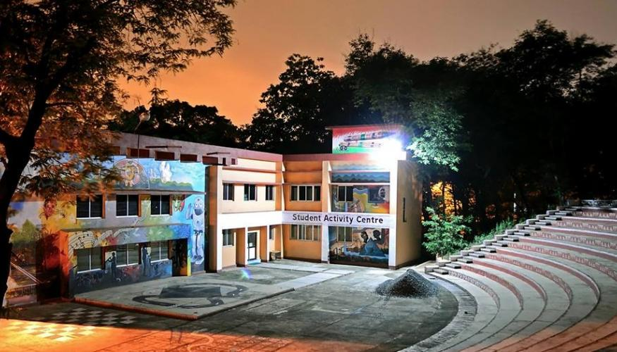

Despite the existence of a very well-ingrained Student Activity Centre, the woes and exasperations of the NITR populace does not seem to be restrained. The inefficacious performance of the SAC committee domineered and persevered until the **Director,** **Prof. Animesh Biswas** decided to reorient SAC to improve the present scenario and to transcend it apace. The chaos related to activities carried out under SAC had to be desisted and the procedures involved should undergo at a ferocious pace. Then again, to ensure justice and rectitude, a certain degree of transparency became highly imperative. Both the club activities and fest activities had to be looked after by the SAC separately and with equal importance. While addressing the plights of the students, the SAC remained quite ineffective with the students bound to come up with their issues themselves. Thus, the SAC rules were reformed to wholly and cordially accommodate the best interest of the NITR student multitude.

The committee which was obliged to carry out such a radical change was appointed by the Director, headed by former SAC President, **Prof. Japes Bera**. The members included **Payal Agrawal, Mohit Gupta, Anup Mittal, Poorva Singh, Pushkar Mishra, Pallerla rajanish reddy, Nishant Kumar Singh, B Narsingh Rao and Debabrata Mohapatra** as student representatives and the VPs of the 4 societies along with 2 SAC office bearers. This panel was summoned to identify the drawbacks of the existing SAC model and propose methods to challenge and obliterate them.

### **SAC ELECTIONS**

The key amendment that **SAC Election** underwent through is the separation of the fest body from the SAC Elections so that proper attention can be paid to the clubs as well as to the fests. Now that the bodies managing the clubs and fests are different, the number of secretaries are reduced to half from 10 (8 elected + 2 nominated) in each society to 5 (4 elected + 1 nominated). Accordingly, three conveners would be chosen from elections (2 elected + 1 nominated) for each of the three fests (Technical Fest, Cultural Fest and the Sports Fest) as proposed by the SAC restructuring body.

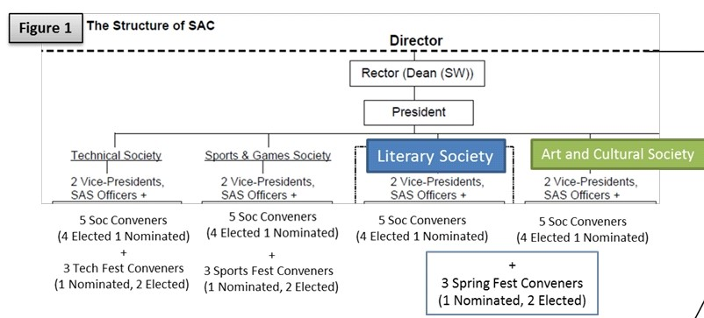

For the SAC society elections, secretaries would be declared winners on the clear majority of votes (as there will be only one seat up for grabs). Since there will be two elected posts for the conveners for each fest, the algorithm for computing the winners is yet to be declared. On being asked about the methods of calculating the votes for fest body conveners, **Prof. S. Chakraverty, President SAC** mentioned,

**The election for the conveners has been delayed owing to the fact that the automation cell is not yet ready to conduct elections for two seats at once. The automation cell is working on making a program for the election of fest body conveners before 15th August. The previous method was quite complex and it may or may not be implemented this year.**

The committee also suggested changes to the algorithm for counting the votes polled. For the convener elections, (2 seats for each fest) each student can vote for 2 students of their choice (Primary and Secondary). The students with the top 2 maximum (Primary + Secondary) votes will be announced as the winner for the particular seat. In case two candidates have secured the same amount of votes, and also have the highest vote count, both the candisates will be declared as the winner. However in case of a tie for the second position, the student with the maximum number of primary votes will be declared as the winner. Under normal circumsatnces however, both the votes (primary and secondary) carry the same weightage, and should be the deciding factor only in case of a tie.

A major negligence was observed this year as two students who didn’t submit the hardcopy of the documents after filing nominations online are still allowed to contest the elections. On this account, **Prof. S. Chakraverty**acknowledged the mistake on SAC’s part and said,

**We accept this lapse that occurred since everything was hurried for the election procedure to fasten up. Such things will definitely be taken care from next time.**

The results of the society elections which were held on the 2nd of August, 2017 are published below:

|  |  |  |  |
| --- | --- | --- | --- |
| **Name of the Society** | **Constituency** | **Roll No.** | **Name of the Candidate** |
| **Technical Society** | Second Year | 116CH0101 | Vamsi Krishna Karella |
| Third Year | 115CE0113 | Amlan Kumar Sahoo |
| Fourth and Fifth Year | 114EC0127 | Sibasish Mohanty |
| PG and Research | NA | NIL |
| **Games and Sports Society** | Second Year | 116MN0550 | Buddiga Bhargava Suresh |
| Third Year | 115MM0510 | Abinash Sahoo |
| Fourth and Fifth Year | 114CR0083 | Mukesh Kumar Apat |
| PG and Research | 216EE4299 | Rongali Charanteja |
| **Literary Society** | Second Year | 116MN0580 | Saurav Kumar Saraf |
| Third Year | 715CR2136 | Harsh Saini |
| Fourth and Fifth Year | 714CR2136 | Rajyashree Lenka |
| PG and Research | NA | NA |
| **Arts and Cultural Society** | Second Year | 116ME0462 | Debasis Mishra |
| Third Year | 115CR0169 | Pratyush Dash |
| Fourth and Fifth Year | 714CE3011 | Ajit Kumar |
| PG and Research | NA | NA |

Team MM congratulates all the winners and wishes them the best of luck for all their future endeavours.

### **SCRUTINIZATION**

The members of the SAC restructuring body suggested a 3 step process for the scrutiny of candidates for the fest body elections including the elimination rounds:

#### **Screening:** The applications will be screened by the ex-conveners of the respective fests along with the 2 faculty incharges.

#### **Stress Interview:** The same panel will then conduct a stress interview for the screened candidates, taking into account their applications.

#### **Open House Debate (OHD)/Soapbox:** The contenders would be directly answerable to the NITR junta and their manifesto will be discussed amongst an audience of students. This would not be an elimination round.

#### **Elections:** Thereby, the NITR junta can elect two conveners.

Although the final decision regarding the above proposals are yet to be taken (considering the conveners’ election is yet to be scheduled), a final decision regarding the same will be conveyed very soon. While favouring the concept of an OHD, **SAC President, Prof.S.Chakraverty** said,

**It’s a very good proposition and we can give a serious thought to implement it. Even Monday Morning can help us in conducting such sort of an event in SAC to familiarize the voters with the contenders.**

The concept of **Open House Discussion** for scrutinising candidates is inspired from similar policies already existing in premiere IITs and private colleges in the country. For instance, IIT Kharagpur organises ‘**Soapbox**’ where competing candidates share their vision as well as past experiences of working with SAC/Gymkhana with the students of the institute in a public debate. A series of cross-questioning ensues as the audience (which includes previous post holders) debates upon the manifesto presented by the candidate.

For the SAC society elections, the process of scrutinization involved only a checking of the minimum threshold CGPA as well as past disciplinary records.

For the current year, for the fest body elections for the conveners, the second year UG students have no say whatsoever. It has been a long drawn process that forbids the first year students from voting for second year or higher constituency as a measure to curb ragging activities. However, considering that fact, that this year by the time of elections, the freshers are now sophomores and reside in the same halls with the seniors so there is no point in continuing it. On asking **Prof. S. Chakraverty**said,

**Assume that the elections are taking place at its usual time, say in April 2017. We are facing such a situation this year because the elections have been delayed from April to August. Since the elections are delayed this year, such situation arose, but from next year, it will get back on track.**

However, following on the same assumptions, the institute also loses the votes of the final year students who graduated in the session 2017-18.

Another issue that surfaced in the SAC society elections is, no nominations were received for two P.G seats. On asking about their plans, **SAC president Prof.S.Chakraverty** said,

**We won’t let the seat go unfilled since the number of secretaries is already reduced to half. We are planning to have a discussion with Director and go for Director’s nominee in this case.**

### **SUGGESTIONS OF THE COMMITTEE**

The first major change proposed by the restructuring committee was a reduction in the number of fests from **five** to **three** annually. A proposal was presented to separate the fest organisation from the society. The objective was to have a separate election for fest convenors and a separate body for organizing a particular fest. There would be three convenors for each fest, two of whom would be elected and one would be nominated. The convenors would work under the guidance of two faculties in-charge, who would govern the overall functioning of the fest. Apart from them, the organizing team of any particular fest would consist of managers, co-ordinators and volunteers, all of whom would be selected by the conveners after a rigorous selection process.

From the above-mentioned proposals, the SAC restructuring committee has accepted to reduce the number of fests to three, the techno-management fest **INNOVISION**, the **Literary and Cultural fest** **NITRUTSAV** and a sports fest. ***Musical Night***, previously called **Celebrity Night**, has been clubbed with NITRUTSAV. A budget of **13 lakhs INR** has been allocated to **NITRUTSAV 2018** as compared to **18 lakhs INR** in NU 2017, the difference of which would be utilized for funding SPIC MACAY workshops.

### **BUDGET ALLOCATION FOR THE YEAR 2017-18:**

|  |  |  |  |  |
| --- | --- | --- | --- | --- |
| **SUB CODE NO. OF NE07/2017** | **MINOR HEAD** | **AMOUNT ALLOTED (IN LAKHS)** | **RESPONSIBLE HOD** | **APPROVING AUTHORITY** |
| NE0701/2017 | SAC Office Expenses | 3.00 | PRESIDENT (SAC) | DEAN (SW) |
| NE0702/2017 | Technical Society (Except Tech Fest) | 12.00 | PRESIDENT (SAC) | DEAN (SW) |
| NE0703/2017 | Games and Sports Society | 12.00 | PRESIDENT (SAC) | DEAN (SW) |
| NE0704/2017 | Literary Society | 15.00 | PRESIDENT (SAC) | DEAN (SW) |
| NE0705/2017 | Art and Cultural Society (Except Musical Night) | 9.00 | PRESIDENT (SAC) | DEAN (SW) |
| NE0706/2017 | Tech Fest | 11.0 | PRESIDENT (SAC) | DEAN (SW) |
| NE0707/2017 | Spring Fest | 13.00 | PRESIDENT (SAC) | DEAN (SW) |
| NE0708/2017 | Musical Night | 20.00 | PRESIDENT (SAC) | DEAN (SW) |
| NE0709/2017 | Inter NIT Events | 7.00 | PRESIDENT (SAC) | DEAN (SW) |
| NE07010/2017 | Miscellaneous Expenses (Director) | 10.00 | DIRECTOR | DIRECTOR |
| NE07011/2017 | Swimming Pool | 13.00 | PRESIDENT (SAC) | DEAN (SW) |
| NE07012/2017 | Souvenir | 6.00 | PRESIDENT (SAC) | DEAN (SW) |
| NE07013/2017 | Counselling | 20.00 | PRESIDENT (SAC) | DEAN (SW) |
|  | SPIC MACAY | 5.00 | PRESIDENT (SAC) | DEAN (SW) |
| NE07014/2017 | Miscellaneous Expenses (DEAN) | 15.00 | DEAN (SW) | DEAN (SW) |
| NE07015/2017 | Miscellaneous Expenses (PRESIDENT) | 15.00 | PRESIDENT (SAC) | PRESIDENT (SAC) |
| **TOTAL ALLOTMENT** | | 186.00 |  | |

The students of SAC restructuring committee also suggested changes to the existing society structure. The proposed proposition included renaming the societies so as to accomodate roughly the samenumber of clubs in every society. Apart from this, they intended to reduce the number of representatives for SAC societies. Previously, SAC societies had 8 elected representatives, along with 2 dean-nominated representatives for each society. As per the committee’s proposal, SAC societies would only have four elected representatives along with one dean-nominated representative per society.

The SAC restructuring committee largely accepted the changes proposed in this regard and all the changes have since been implemented. The number of student representatives has now been reduced to 5 per society. The SAC societies have also been renamed to inculcate roughly equal distribution of clubs per society.

### **PROPOSAL FOR THE STUDENTS COUNCIL**

The students of restructuring body proposed a **Student Council**, which is independent of any other body, society or organization of the NIT Chapters and is solely answerable to the **Director** for acts of omission and commission. The suggested hierarchy was as follows:

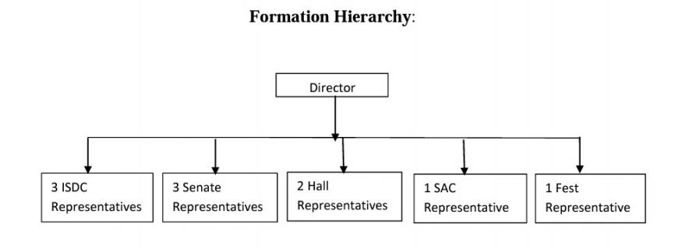

On enquiring as to why the idea was scraped, former SAC President, **Prof. Japes Bera** said,

**It wasn’t discussed in the meeting because it has a wider scope and is not just confined to the matters concerning student activities and SAC. It was proposed to be directly under the Director because keeping it under SAC would not fulfil the motive of its inception. In my views, this is a very proficient concept and should be taken forward in consultation with the Director.**

After years of glitches and adversities, the new Director opted for a newly reformed SAC to uplift the existing standards, encompass the satisfaction of the students, and effectively answer to their requirements. Team MM clearly presented the unbiased facts related to how and what changes could be brought to effect. Now the spectators of NITR are left to judge its effectiveness on the present scenario and with the elections drawing so close, Team MM expects the NITR junta to cast their invaluable vote fairly and rightly.

10.NTPC ELECTRON QUIZ

3/8/17

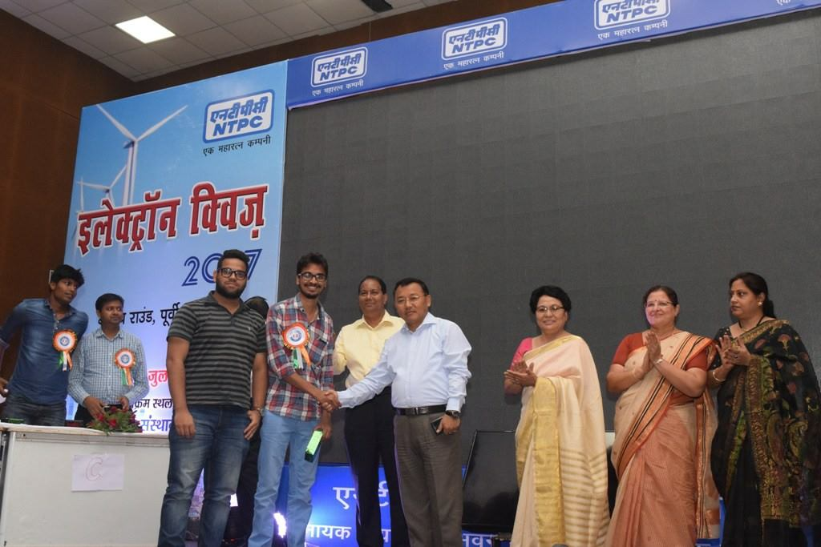

NIT Rourkela Team has won the NTPC electron quiz 2017 , a regional level competition organised for NTPC Eastern Region-I , Patna.

NIT Rourkela representatives, Nishant Nihar and Abhishek Patra won first prize held at Chandragupta Institute of Management (CIMP ) campus. They have been awarded Rs 30000 by NTPC Regional Executive Director (East-I) , K S Garbyal. This would not have been possible without the effort and guidance of Mr. Sampad Mishra, 2008 alumnus of NIT Rourkela , currently working with SAIL as Deputy Manager.

A total of 52 teams from various engineering and mangement colleges across Bihar, Jharkhand and Odisha took part in the Quiz competition and top three teams would take part in the national level to be held at NTPC Business School Noida on August 19. All the very best to NIT Rourkela Team for finals.

Social Media, NITRAA with [Anup Agarwal](https://www.facebook.com/anupagarwal91?fref=mentions), [Nishant Nihar](https://www.facebook.com/Nishant.Nihar?fref=mentions) [Nit Rourkela Nitraa](https://www.facebook.com/nitraa.gs?fref=mentions)[#NITRAA](https://www.facebook.com/hashtag/nitraa?source=feed_text&story_id=1094469337354684)

11.

# NITR: TRANSITION TO TOP GEAR

31/7/17

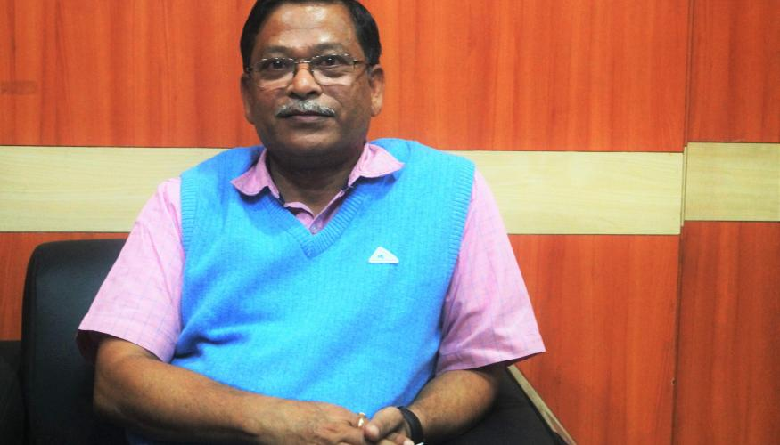

With the onset of the new session, a wide array of issues can be witnessed at the institute. Team Monday Morning approached our honorable **Director, Professor Animesh Biswas** to discuss on certain topics. A vivid picture of the discussion has been presented here.

**MM: The academic syllabus hosted on the website has not been updated since the last few years. The list of subjects as well as their codes has not changed on the PDF, although in reality they have changed too much. What steps are being taken in this regard?**

**AB**: The task of updating the syllabus is in process. The automation cell of our institute has been approached in this regard and Professor Sarat Patra is looking into this matter. Since, making the entire curriculum up-to-date will take some time; we are primarily focusing on updating the first year syllabus on a priority basis.

**MM**: **The academic curriculum for the first year has been revised completely. Will this be implemented for other batches also? How will the number of credits change for the first year students?**

**AB:**This new curriculum has been introduced only for the first year students. The overall credits have been reduced for the fresh batch but the depth of course will increase factoring in regular assignments and proper student-teacher interaction. The objective is to keep students’ engaged so that they enjoy what they learn. Other batches from second year onwards will run as per the previous system. So, two parallel curriculums will function simultaneously until the 2016-2020 batch graduates.

**MM: Given that the curriculum has been revised, have the faculties been provided with any special training with regards to that? Also some departments were already facing a shortage of faculties. When can we expect the vacancies to be filled up?**

**AB:**All the faculties were involved in the revision of the curriculum so; they are competent enough to handle it in the first place. However, the teaching methodology solely depends on the discretion of the faculty members. Considering the vacancies in different departments, we will be publishing “**Faculty Position Advertisement**” on 31 July 2017. It may take some time to fill up the vacancies as it is a long process and requires approval from MHRD (Ministry of Human Resource Department) as well.

**MM: The building for Mechanical Engineering department, the Golden Jubilee Building & the Lecture Annex 2 are under construction for a long time. When can we expect them to start functioning?**

**AB:**The construction works are in progress under the **Shapoorji Pallonji** group who has ensured to complete the job by March 2018 hopefully. We can expect the LA 2 be functional by **December, 2017**. The cash flow from the ministry was disrupted earlier but it has been regularized from this financial year.

**MM: Pre-final year boys are being offered single rooms but girls of pre-final year do not enjoy the same facility. Moreover CVR hall still has the dormitories functional. Are there any plans to set-up a new girls’ hostel?**

**AB:**Every year the number of female students changes. This year also we witnessed a decrease in the number of girls. So, we have no plans for setting-up another girls’ hostel in near future. Things will definitely be brought into action, but presently we have decided to build a new hostel for married students.

**MM: There was a recent fee hike in the postgraduate fees and it was protested by the students as well. Can you shed some light on how the issue will be resolved? Also, there were talks about abolishing the book fee and reduction of SAC fees (considering the decrease in the number of fests).What can be said about these issues?**

**AB:**The Finance committee recommended the fee hike in 2015. However, any recommendation made by the FC has to be approved by the BOG first only then can it be implemented. As BOG meet didn’t takeplace for last few years due to certain issues the proposal was put up in BOG meeting convened in the month of April, 2017, which approved the FC’s recommendation. Accordingly, the fee hike was implemented from this year only. Now, BOG wants that an “Action Taken Report” has to be submitted which will include all the recommendations made by the FC. Since it took a few years for the BOG to make the final decision, any proposal for fee hike was stalled for last two years. The extra amount which was collected last year as HAIF was only a small part of the proposal for the hike which was implemented by the former Director. Now BOG has approved the whole proposal and we have to accept the decision. Considering the agitation by the postgraduate students, we have constituted a committee to look into it and further decision regarding the hike will be taken based on the findings of the committee.

There is also the factor of the ‘**Minimum Wages Act**’ wherein the wages of skilled and unskilled labourers are revised regularly. This also demands more money to meet their payment.

Whenever a new financial year starts, a new budget has to be submitted. What happened in case of HMC, the expected expenditure presented is more than the cash inflow. Therefore, I did not accept the current budget proposal and requested HMC to submit a revised budget proposal.

The book fee has been abolished, as it was one of the very first thing I tried to implement. Students should have the freedom to buy and purchase their own books at their own will. SAC fee has not been revised as BOG decided to maintain status quo.

**MM:** **A) You had previously mentioned about your wish to promote undergraduate research work. What steps will be taken this year to promote and facilitate the same?**

**B) Many institutes have Central Research Facilities which cater to students of all streams. Can we expect something like that in NITR?**

A) Provisions have been made in the revised curriculum to allow students to take up project work. It is purely optional as not every student is interested for a career in the research sector, but for those genuinely interested in research & development work, this is a very good opportunity. We have begun interactions with some concerned authorities who provide internships to increase research opportunities for the students as well.

B) With regards to the Central Research Facilities, we are setting up a Central Instruments Facility at NITR to expose students to the latest apparatus of Science and Technology. We are trying to bring equipments from every department under a central umbrella to improve ease of access. It will be expanded under the leadership of **Prof.Mukesh Kumar Gupta of the Biotechnology Department**. The facility will provide access to high-end equipments to students of all streams and eventually industries too. Training programs for technicians and staff to operate these high end equipments will be organized in summer. For the students, this will promote multidisciplinary research work & providing such facilities to industries will aid industrial development too. Also we can expect to generate a source of income for the institute. The facility is expected to be functional from current financial year onwards.

**MM:** **Do you have any plans to expand the horizons of the TIIR building?**

**AB:**I am interested in encouraging incubation of start-ups from the students and alumni of the institute. We are in the process of interacting with agencies to sponsor any new incubation. The location and difficulty to commute often remains the bottleneck hindering these developments, but we hope to overcome that soon. Prof.S.S.Mohapatra has been appointed as in-charge of this endeavor. This will immensely benefit the students who aspire to be entrepreneurs and it will boost the rankings of the institute.

**MM: Considering the NIRF Rankings 2017 of Engineering colleges in India, NIT Rourkela has definitely performed well in all parameters and secured a 12th all India rank. However it was marked that the scores of NITR were quite low in the perception parameter. Why so?**

**AB:**There are basically two reasons for same. Firstly, people in this country are not so aware that a quality technical institute exists in this part of the country. Second and most important factor was that the students and alumni didn’t respond in large numbers or positively on the occasion of filling out the form for this parameter.

From my point of view, the way to boost perception about the institute is to strengthen and perfect the teaching & learning process as well as all other areas, so that our students automatically feel driven to respond and give honest positive reviews.

**MM:** **Are there any plans to digitize the SAC and HMC budgets? What other plans are in the pipeline**?

**AB:** In my opinion, all systems should be transparent & SAC and HMC budget allocation is definitely one of them. It would be wiser to contact SAC on this matter and propose this.

Regarding other changes, the basketball court is being revamped. Two lawn tennis courts, which were in very bad shape, will also be revamped to match international standards. **Prof. C.R. Patra** is working on the same project.

**MM:** **The alumni relations suffered a setback in the past few years. How is the institute working on reviving it?**

**AB:**I admit that alumni relations haven’t been strong enough historically too. However, Alumni play a very vital role in the development of the institute.

**They increment the repute of the institute; provide opportunities to our students and also assistance to students who may require it. So I have furthered interactions with the Alumni, requesting them to collaborate with the institute to bring Nobel Laureates and other eminent proponents of the Science & Engineering field. I have also requested the Dean Alumni to develop a calendar and conduct interaction sessions with noted alumni in the campus. Both these proposals have been approved by NITRAA. The requirement is that all the parts of the institute should grow in a positive note, without any bitterness.**

12.A LAYMAN’S LAYOUT NITR

19/7/17

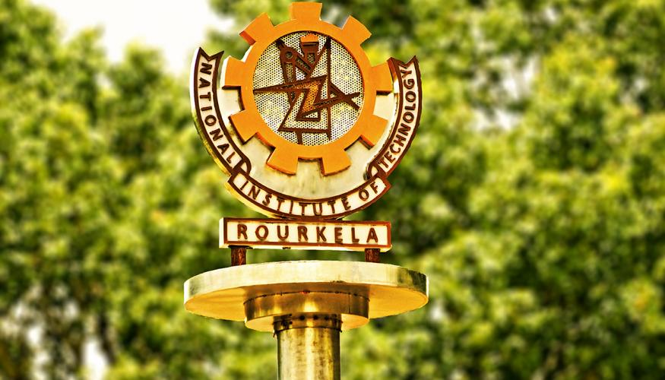

After having alighted the respective Expresses, the freshmen might be brooding over what they are headed for, a life of drudgery probably? Still doubting their decision or lamenting? Encompassing an immense diversity both in terms of ethnicity and intellectual interests, NITR represents the epitome of excellence. While the freshmen might be an utter enigma which way to head on and how to adjust in a new arena, Team MM has made a handy guide to make their survival in this magical world easy.

National Institute of Technology, Rourkela has made its way into the prestigious lists, ranked 19th by the Times World Asian University and 12thby the NIRF among the Indian Engineering Universities. Team Monday Morning, having spent a decade here, assures that if you still regret being born a muggle or not receiving your Hogwarts letter, NITR is indeed, **the Hogwarts of Engineering**. Here, take a look:

## ****BIENVENUE TO THE ABODE OF SERENITY****

Popularly known as the Steel City, Rourkela serves as the industrial capital of Odisha and houses one of the National Institutes of Technology (NIT, Rourkela). Hogwarts can keep its forests and lakes; because Rourkela has its very own lush, green forests and the bubbly **Koel River.**It experiences a tropical climate with summers as high 49 degrees and winters as low as 5 degrees.

While Sector -2 market, Ispat market and Ambagan act as the Hogsmeade, catering to the tiniest of needs of the NITR junta, Udit Nagar main market serves to be the DiagonAlley of Rourkela. A 16-km long Ring Road connects the various sectors of the city.

## ****HEADING TO NIT-R****

The following section details how to reach NITR and how to make your initial days smoother.

### **REACHING ROURKELA:**

**Rourkela,** located in the northern part of Odisha, surrounded by a range of hills and swift rivers, is well connected to rest of the country by rail and road. The nearest airport cities are**Ranchi, Raipur**and**Bhubaneshwar,** listed in increasing rail distance from Rourkela. Interstate and intercity bus services to several nearby cities are also available. In addition, a **City**bus plies from station to Sector-2, the nearest bus stop from the institute.

The **auto drivers** charge a fixed fare of Rs.120 to the NIT campus. Booking an **Ola cab** or **car rental services** is another option for commuting in the city.

### **TEMPORARY ACCOMMODATION:**

The soon to be wizards of engineering will surely be accompanied by their parents & guardians to NITR. Rourkela has an array of hotels which can cater to their accommodation needs. Here are some hotels & lodges which may be viable options to provide restful lodgings in the links given below:

<http://www.nitrkl.ac.in/IndustryAlumni/11Travel/Hotels.aspx>

<http://guesthouse.nitrkl.ac.in/Users/HomePage.aspx>

## ****ALERT: THE NECESSARY SUPPLIES!****

For personal care products, **Rangoli**is located conveniently in the hostel area in proximity of the first year hostels. Necessary amenities like mattresses, pillows, buckets etc. are available in the hostels for the incoming boarders. A trunk with a lock would be suggested for the safety during year-end vacations.

The marketplace closest to NITR is in Sector 2(1.8km) which is smaller than Ispat market (Ambagan) farther away at Sector 19 (5.5 km).Located in the heart of the city is a larger and elaborate market area including a **Big Bazaar**for all your needs.

## ****DELVE INTO THE NITR BAILIWICK****

Traversing across a vast 1200 acre campus, NIT Rourkela has one of the largest campuses in the country. Amidst the lap of greenery and serene haven, NITR has an array of natural beauty with a well-planned infrastructure. It is physically demanding to stroll in such a huge campus, a bicycle is a necessity, and can be purchased at the time of admission from retailers camping in front of Bhubaneswar Behera Auditorium.

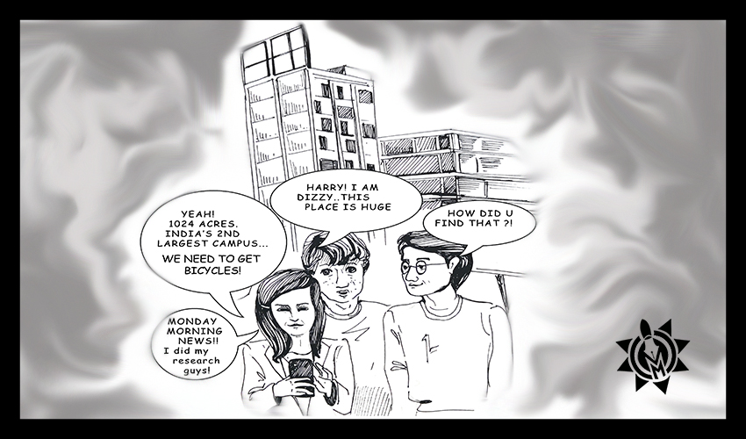

Although the mess is pretty benevolent to provide non-veg food six days per week on some days it might test your patience. For a change from the mess food, there’s an array of food joints available; ranging from **Jo’z Kitchen** and **Hexagon** in the Scholar Avenue to **Mokshaa** and **Dosa Plaza** in Technology Avenue to **Rengcol** and **Srinivasa Lunch Room (SLR)** in Academic area, the diners accept card payments and stay open till late at night to satiate your taste buds. Can’t get you those magical confectionary Honeydukes but hangout places like Nescafe, Departmental stores near the campus gate and **Amul Parlour** enamours you by rendering a wide range of food items and beverages to choose from. Apart from that, there are fruit stalls in front of Ceramic gate for the fruit lovers.

All work and no play make Jack a dull boy. Well, NITR takes care of that too. Extra-Academic courses are further divided into NSS, NCC and PE classes with regular jogging in designated two days of the week. To avail cash in times of need, we have our very own Gringotts, the SBI bank and four ATMs which are located within the campus premises. The two SBI ATMs are conveniently situated near the first year boys’ hostels while an AXIS ATM and an SBI ATM is located in the Academic area and Residential area respectively. Furthermore, there are three temples in the campus for the ardent devotees.

## ****HOSTEL LIFE****

NITR flaunts a total of 10 halls of residence; **7 for boys (GDB,MV,MSS,DBA,VS,SD,HB**) , **2 for girls (KMS,CVR**) and **1(SSB) for the married students**. The office of the chief warden is the ‘sorting hat’.**GDB** and **MV**are exclusively allotted only to the freshmen boys as an effective means to curb ragging whereas girls are assigned rooms in either**KMS** or **CVR**. Each hall of residence is maintained by an HEC (Hall Executive Council) which comprises of the Warden, Assistant Wardens and student elected secretaries. The HMC(Hall Management Council, headed by the Chief Warden) is the umbrella organisation as it oversees the working of all the HECs.

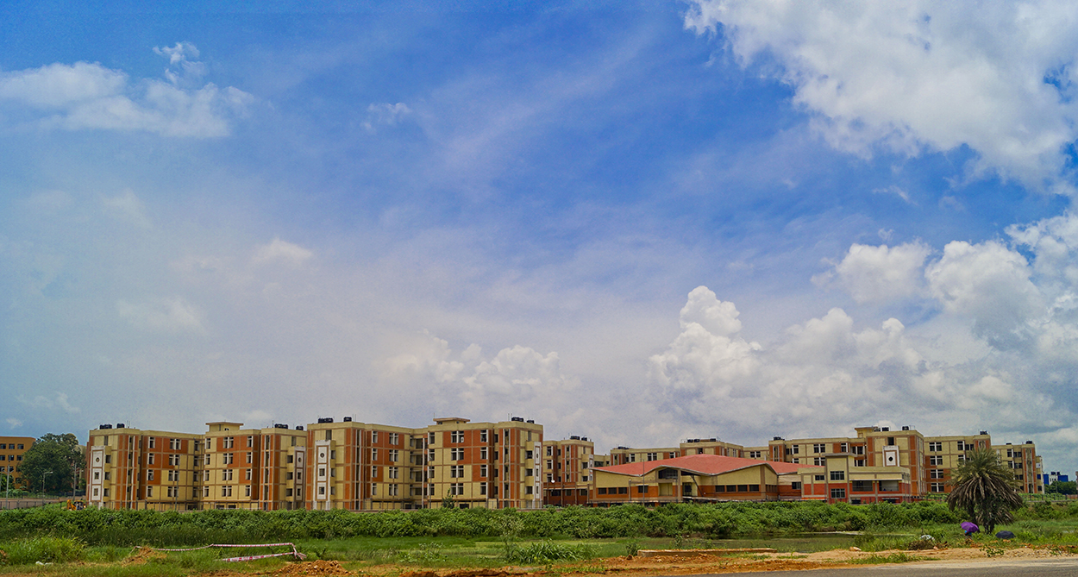

Keeping in mind the nutritional necessities of the boarders, all the halls are complete with a mess whose menu is updated at least twice a semester and students play an active role in deciding it. Day canteens and night canteens with fixed rate charts are present so that the students can satiate their untimely cravings. LAN port/s in each room provides high-speed internet connectivity. Apart from that, a table and a chair are provided for each boarder. All the blocks and corridors are well equipped with aqua guards providing clean and cold water, regularly sanitised bathrooms with exhaust fans and geysers, an adequate number of garbage bins. With all the halls being facilitated with a Common Room, TV room, Reading Room, Games Room, outdoor courts for sports, big cycle parking areas, washing facilities at nominal prices, departmental stores; what more could one ask for?  With so many Hall events buzzing all around the year such as hall day, foundation day, garden feast and inter as well as intra-hall tournaments, the boarders get a whale of the time.

With security staff stationed right at the gates of every hall, this ‘Hogwarts of Rourkela’ doesn’t compromise on the safety of its students. In addition, fire extinguishers and a list of emergency contacts are present in every hostel including contact numbers of on-call doctors and electricians.

For more information, click here:

[**http://nitrkl.ac.in/CurrentStudents/8HallsofResidence/Default.aspx**](http://nitrkl.ac.in/CurrentStudents/8HallsofResidence/Default.aspx)

## ****ACADEMICS AT NITR****

NITR has a very well-structured and rigorous academic curriculum which extracts the best out of any student thereby helping him to attain his/her ultimate potential. Other than that, your support hotlines also include our very own owl posts—the ‘Z**imbra webmail’** and our educational forum—**Moodle** where information is continuously exchanged and uploaded. It is readily accessible 24*7 using your hostel LAN. Attendance is an important factor with 85% as a minimum requirement.

Then there are our very own ‘newts’ and ‘owls’ of the muggle world, for all theory subjects and Viva for lab/sessional courses. At NITR, every semester, there are two main examinations: the Mid-Semester and the End-Semester exams, conducted within a gap of two months.

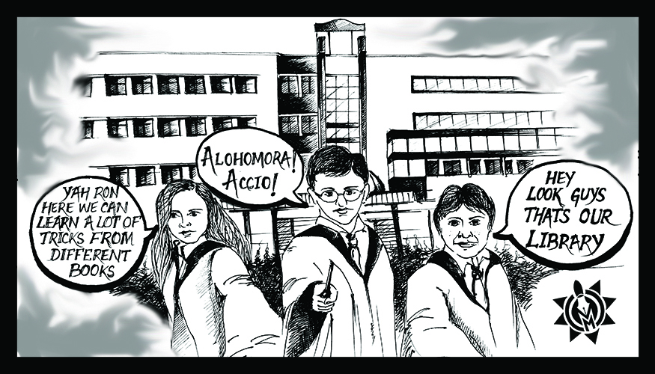

For those not familiar, [NITRIS](https://eapplication.nitrkl.ac.in/nitris) is a one-stop portal for your entire academic profile, from attendance to results, academic calendars, exam routines, grades and everything associated with it. The **branch change rule will be reintroduced from the upcoming session** keeping in mind that it provides an avenue and opportunity to a student to pursue the subject of his/her choice and interest.

The **Student Mentorship Program** is an exceptional initiative of Monday Morning where experienced mentors provide personal and professional support to the eager and curious newbies, thus enabling constructive and positive interaction and guidance.

The number of branches and specialisations in NITR is the highest amongst all NITs. There is always some cutting edge research going on in every department of the institute. NITR has state-of-the-art infrastructure and a very conducive environment required for research activities. The meticulously charted out curriculum gives you an edge over others in terms of knowledge and the technical acumen.

## ****EXTRA-CURRICULAR ACTIVITIES****

Apart from the excellent academic facilities, NIT-R also serves as a great base for extra-curricular activities, which serve as an escape from the academic monotone. The good sporting infrastructure includes the Cricket Stadium (**Sachin Tendulkar Sports Complex**), football and hockey stadium (**Dilip Tirkey Stadium),** tennis courts, volleyball court, basketball courts and an indoor badminton court**.**

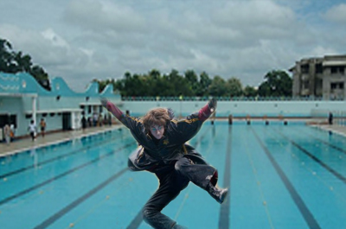

**Dilip Tirkey Stadium (DTS**), equipped with dazzling floodlights and a pavilion is the place of worship of the sports enthusiasts and also serves as a place for pro shows and EDM nights. NITR also boasts of a well-equipped central gym and a floodlit Olympic sized **swimming pool** with 8 lanes. The college is an active participant in all inter-NIT sports events, subsequently providing ample exposure to the students. The students have won laurels year after year and in the recent Inter-NIT tournament, the cricket team of NITR emerged victorious defeating 27 other teams from several NITs of the nation.

Apart from this, we have intra-hall events, a series of competitive events held amongst the various residents. There isn’t an iota of chance for getting bored.

“Wingardium Leviosa” – You certainly don’t need this to levitate in the much-hyped fests at NIT-R. The ostentatious preparations, the extravagant fun nights planned alongside the majestic events will get your wand waving all day without any pause.

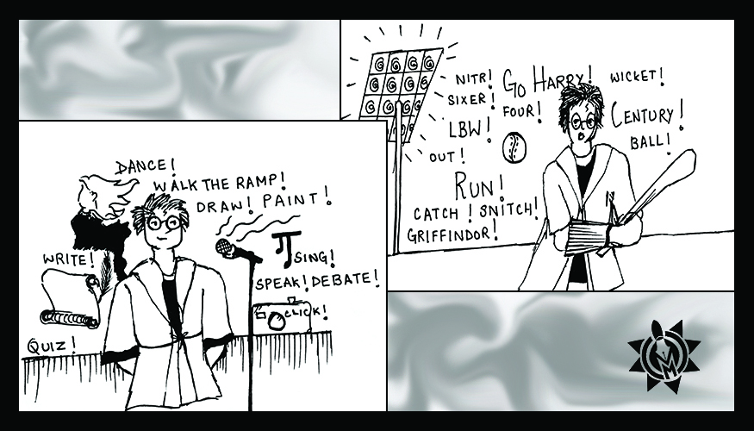

NIT-R enjoys equal glamour in bringing different colleges of the nation down to Rourkela. This wizarding year will witness three fests – one technical, one cultural and another in sports. Complemented with brainstorming events, celebrity night, soulful bands and exploding DJs the fests usually end up with many grandiose and high spirits.

## ****THE SAC & CLUB CULTURE****

The **Student Activity Centre**, NITR’s very own Order of Phoenix**,**is a conglomeration of the most variedly talented individuals. SAC oversees the working of four societies; Technical Society, The Literary and Cultural Society, The Games and Sports Society and The Games and Sports Society. SAC oversees the working of various satellite clubs registered with different societies. The clubs under **SAC** can weave magic with pens or mesmerise you with their music or work day & night to roll out rumbling formula cars which seem like they could fly any second.

Debating, robotics, music, dance, art, cooking, martial arts, coding, drama, automobile engineering are some of the activities which take place in the respective clubs. The sedulous hard work of the members of this order inside the SAC precincts remains invisible to the NITR junta, just as Number Twelve, Grimmauld Palace remained to the muggles.

## ****THE GATEWAY TO A SUCCESSFUL FUTURE: PLACEMENTS****

While the odds of us engineers going to work in the Ministry of Magic or the Auror Office aren’t very high, we do have some pretty amazing placements of our own on campus. With the dawn of a new placement era and several changes in its existing policies, NITR manages to become a part of the elite institutions of our country.

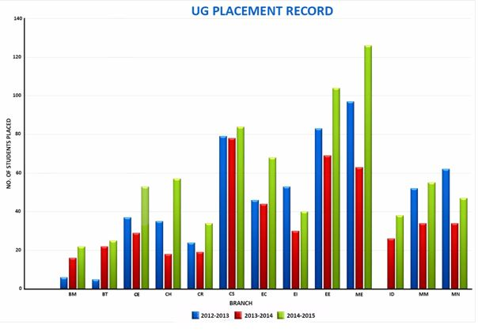

Besides mass recruiters such as **TCS** and **WIPRO,** the campus is visited by some of the most prestigious companies in the country such as **Deloitte, Microsoft, Amazon, Samsung, ITC, Vedanta, Coal India Limited,**and **Goldman Sachs** to name a few. The **Training** and **Placement Centre** along with a group of dedicated Placement Coordinators work hand in hand to help students through the various rounds of selection. To get more details about the placements from the Institute, you can refer to the following link:  
<http://mondaymorning.nitrkl.ac.in/placement-stats>

While most students choose to go for their dream jobs, there are some people like Hermione that have a thirst for higher education. The academic outline is designed to give ample of time to pursue their subject of interest. Thus the students of NITR have managed to achieve excellent scores in GATE as high as [**AIR 9**](http://mondaymorning.nitrkl.ac.in/2017/05/23/1232-climbing-the-unsurmountable-divya-siramwar/) in the past academic year.

The campus has also witnessed the birth of a great number of start-ups such as **MySmartprice, Phoenix Robotix** and **Penny India.**Penny India was the brainchild of two first-year students, who are continuing their studies in the institute besides owning their dreams of entrepreneurship. The TIIR (Technology Innovation and Industry Relations) provides a platform for budding entrepreneurs and acts as an incubation centre for developing business.

Here’s the link to the placement brochure of NIT Rourkela for the year 2016-17:

[Placement Brochure 2016-17| NIT-R](http://nitrkl.ac.in/IntraWeb/PlacementBoucher/2016-17/161011432612_1.pdf)

## ****ALUMNI RELATIONS****

It’s not a myth. NITR does brew spells for its great sorcerers to obtain a strong hold in this vast world. To prove this assertion, many alumni allow themselves to be examples for the world to witness. Have a look.

* **Soma Mondal**, an alumnus of 1984 has been appointed as the **First Woman Commer Director of SAIL**, in March 2017 as has been breaking gender stereotypes.
* **C.P Gurnani,**an alumnus of Chemical Engineering is currently the CEO & Managing Director of **Tech Mahindra.**
* **Akash Khurana,** a notable Indian Actor, screenwriter, theatre artist & entrepreneur, is an Alumni of Mechanical Engineering from the Institute.

**NITRAA**or **NIT Rourkela Alumni Association**, which helps in bringing the alumni around the world together through its websites’ database. The NITRAA executive council is headed by **Venkata Narasimham Peri (India Chapter)**. Every year NITRAA conducts alumni inductions during the annual homecoming to welcome the outgoing batch to be a part of the association. Our institute also witnesses various events where students get to interact with their alumni in an effort to strengthen the student-alumni relations. The alumni have a great zeal to work for the institute and have created multiple opportunities for the students to prosper in every possible field.

## ****HASSLE AT THE MAGICAL CASTLE?****

At certain instances, if you fall ill, just a walk to the **dispensary** can be the solution for all your solicitous health problems. Getting yourself treated by our very own Madam Pomfrey’s and fetching medicines free of cost from the **Apollo Pharmacy**near the dispensary is an amenity sure to curb all your health-related woes. Serious health issues can be dealt at two significant hospitals, **CWS** and **IGH upon**referral from the institute doctors.

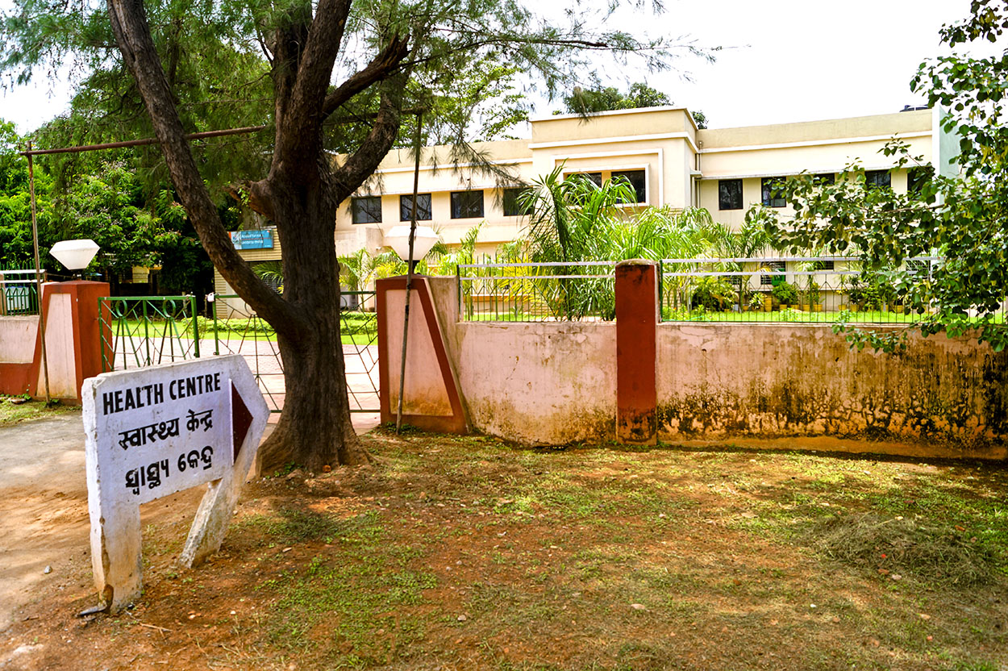

Unfortunately, if you lose any Prophecy Orb or misplace your Portkeys, feel free to contact the security officer of NITR. In case of any academic glitches, you can get the issue resolved at the Assistant Registrar’s office. Apart from this many issues get answered through the webmail sent to the students and faculties. To acquire the contact information of chief authorities you can click on the following link. (<http://nitrkl.ac.in/Links/ContactUs.aspx>)

NITR is your HOGWARTS where you enter as a naive magician with lots of doubts and expectations but is certain to provide you with unending opportunities to learn and achieve everything that you crave for, in short, “**it is your internship to life, ahead**”.

Be it any scholastic perplexity or personal anguish, your cordial seniors will always help you out of the difficulty. The absolutely ragging free campus will definitely makes your stay at this dreamland worth cherishing.

***Help will always be given at NITR, to those who ask for it.***

Being the official e-newsletter of the institute, **Monday Morning** shall always be present to lend a hand in case of adversities. You can reach us through the website, mobile app and can even call to get in touch with our Chief-coordinators, mentors or reporters. In case of queries, you can post them by visiting the following link and or through the official Facebook page of Monday Morning.

<http://mondaymorning.nitrkl.ac.in/ask-a-question>

<https://www.facebook.com/mondaymorning.NITRKL/>

Extending our heartiest greetings, we welcome you to this magnificent family!

13.

20/6/17

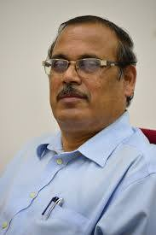

The song has ended but the melody lingers on… – Irving Berlin

Dr. Sanjay Kumar Jena, Professor of Computer Science passed away on the evening of May 17,2017 after suffering a fatal heart attack. He was rushed to the hospital but was pronounced dead on arrival.

NITRAA expresses its deepest condolences and shock at the sudden demise of Dr. Jena who was on his way to attend his daughter’s wedding in Bhubaneswar to be held on the 21st instant. His fellow teachers led by the Director, the alumni and students have joined together to express heartfelt condolences at the sudden turn of events and cruel fate that took away a loved, humble, brilliant teacher; a doting father and a loving husband.

A proud son of Odisha, Dr. Jena was born on April 28, 1954. He did his schooling in Cuttack; Pre-university studies at the reputed SVM College in Jagatsinghpur. He enrolled for his BSc (Honors) in Mathematics at the Government College, Rourkela and then joined NIT, Rourkela (then the Regional Engineering College at Rourkela) for his M.Sc in Mathematics. He pursued his research at IIT, Mumbai and returned to NITR as a Lecturer in 1984. Over the next 3 decades he would become a brilliant researcher (with 1094 Google Scholar citations and a Gold Medal for the best paper in 2002 at the CSI in Bangalore); would serve with distinction as the Head of the Computer Science Department from June 2004 to June 2007 and would take up a number of administrative responsibilities including serving very recently as the Dean for Training and Placement where he endeared himself to many alumni with his welcoming approach for suggestions for improving the placements and training. Above all, he was a loving teacher who was just a step away to help his students and remained a simple, humble, caring human being. Having served the institute for 32 years, his presence, guidance and affection will be missed on the campus and among alumni. Dr. Jena is survived by his wife and two children.

Reacting with shock, the President of NITRAA, Venkat Peri said – “Dr. Jena was my teacher. He was one of the finest, willing to walk that extra mile to answer questions and offer guidance. He was the one who laid very strong foundation of mathematics amongst many students. In the last 2 years, I have interacted with him many times – both on opportunities to improve the research and teaching environments in the department and in the institute and also bringing more corporates to the campus not just for placements but for collaboration and learning. His passion, commitment and affection was infectious and he will be missed deeply. On behalf of all the alumni, I offer deepest condolences to Mrs. Jena and family and friends and I pray that he will continue to bless us and that the Lord give his family the courage to pass through these trying times. May his soul rest in peace. We will miss you Sir!”

In his memory, NITRAA will institutionalize an award from the coming year which will be given to the best graduating student of the Computer Science Department. In the subsequent weeks, the alumni will work with the Director, the Head of the Department and his family to put the framework for the selection.

Team NITRAA with [Anup Agarwal](https://www.facebook.com/anupagarwal91?fref=mentions) [Leo Kurians Paulose](https://www.facebook.com/leo.k.paulose?fref=mentions) Suresh Venkataraman [Saroj Kumar Patel](https://www.facebook.com/skpatel85?fref=mentions) [Pushpdant Vandana Jain](https://www.facebook.com/pushpdant.jain?fref=mentions)

14.

Alumni of the week:subrat pani

6/5/17

**Subrat Pani, a distinguished alumnus of 1991 batch of Electrical Engineering, NIT Rourkela, and IIM Calcutta, is currently the co-founder of One Assist Customer, a B2B Company having over 8 lacs subscribers.**

Having his roots in Rourkela, he used to be a day-scholar in his first year after which he transitioned into hostel life. He recollects:

**"Life used to be great and I made a lot of friends. There used to pretty limited career options and one was happy settling for any job after graduation. Also, the number of students opting for higher studies was abysmal and MBA was just coming up as a lucrative career choice. Interestingly, I accidentally decided to pursue an MBA degree."**

In his third year, while his focus was on gaining the technical knowledge required for a core job, other students would discuss their preparation strategy and sample scores in mock CAT tests. This buzz among the students made him try out the test once for himself and what he found was surprising. He really liked the approach of the test and scored quite well in the first attempt itself. That was how he made up his mind that he was meant for CAT. Following that incident, he started reading more and prepared in whatever way he could, as he didn't have the help of the Internet back then. But fate had different plans for him.

In **1991**, when he took the test again, the entire format of the test was reformed  and he couldn’t clear the test. He settled for a **core job at SAIL**, still with the steely resolve of acing the test the following year. After working for almost two years at SAIL which he now calls "flat-out boring", he took the test and came out with flying colors.He shares:

**"I didn’t write any other test, nor did I apply for any institute except for the IIMs, as I was quite determined hat if it was not in the IIMs, I wouldn’t do an MBA at all,",**

That was indeed quite a high-risk step to take and when he looks back now, he finds it was he was lucky to pass it. He was apprehensive about the next selection process i.e the group discussions and interview. Though he was an extrovert, he wasn’t that great in public speaking. But with extensive preparation and a lot of confidence, he aced the interview and got admitted into IIM-C. Now being on the other side of the interview board, he remarks that public speaking is not the only skill that lands one in the IIM’s. They also put a lot of emphasis on traits like originality and creativity which distinguishes an individual from the masses.

In IIM-C during that period, the academic curriculum was entirely different from the other IIMs - there weren't any attendance criteria, and people could spend the entire semester not attending a single class and still pass the course as long as they managed to pass the final exam. Thus the entire freedom of learning was handed over to the student. At IIM-C, he says:

**"We were all toppers and everyone had a story of how they had got here. I had batch mates who could read books like magazines and finish them within 2-3 days. Thus scoring 0 and negative in tough papers like statistics and finance in the initial semesters jolted our ego and brought us to reality."**

He regrets that he had not performed academically that well in his class. Even though he had aced his major papers of Behavioural Science and marketing, he had not done well in minor papers which landed him with an average percentile. He therefore did not get into the FMCG brands which he dreamt of but had to settle for a job with **Godrej**. He got posted in Kochi where he was not comfortable because of the language barrier and the non-metropolitan atmosphere.

Then he joined Arvind Mills and later in 1999 he got into GE, which was a financial venture with SBI. After that he worked for ICICI Bank but surprisingly he left the job to be the business head of cards business of a smaller company **KOTAK**.  He says that possibly 10/10 people wouldn’t have taken this decision but for him it was important to be at the helm of the organization, leading the team. **From his corporate experience he shares that the most important things he learnt is that you have to be passionate in your work and not merely stick to performance expectations and deadlines.**You also have to ensure that other people will enjoy working with you. Talking about his corporate experiences, he says:

**I can say that my most unique achievement was with ICICI Bank when my team had launched the 5% ‘cashback’ associated with credit card purchase in 2003. The term was introduced by us in the Indian Market. People did not know then what cashback was. We brainstormed into some of the foreign markets and came up with this term which is now heard in ecommerce industries nationally.**

He expressed his concern over the lack of a proper network between the current students and alumni. It was palpable when he had visited the institute last year during the Silver Jubilee Celebrations. He believes that the students have a lot to benefit from the alumni, apart from mere advice. He stressed the importance of networking in the current scenario, where there are so many senior experts among the alumni who can benefit the students in a large way.

He finally says that his advice to the NITR Junta nowwould be,

**Unless the sail is fixed, the ship cannot reach its destination. You also need to have listening skills and hear other people's opinions and not assume that you already know everything. In hindsight these are the things which worked for me. So it’s best if you can make up your minds about what career path you want to go down, so you can work for it passionately and ultimately excel in it.**

14.

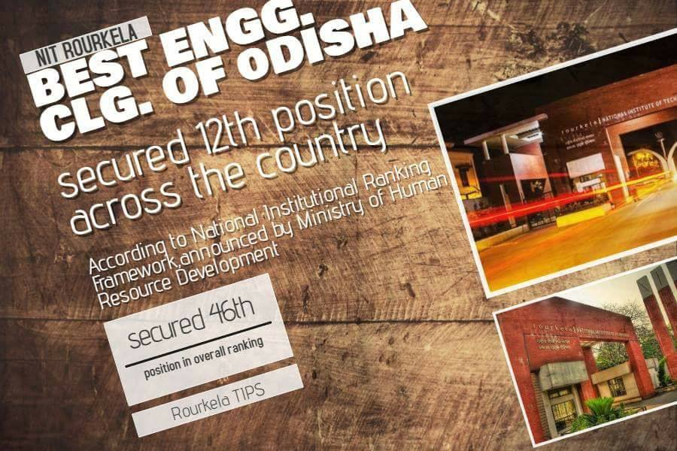

4/4/17

NIT Rourkela became the best Engg. college of Odisha and got 12th position all over India. In overall ranking it got 46th position across India after Ministry of Human Resource Development (MHRD) announced top 100 Engg. college of India yesterday.

The national rankings, introduced last year, are based on broad parameters such as Teaching, Learning and Resources, Research and Professional Practices, Graduation Outcomes, Outreach and Inclusivity, and Perception.

Share your views.

[#Share](https://www.facebook.com/hashtag/share?source=feed_text&story_id=1011083362359949) [#NITRAA](https://www.facebook.com/hashtag/nitraa?source=feed_text&story_id=1011083362359949) [Nit Rourkela Nitraa](https://www.facebook.com/nitraa.gs?fref=mentions)

Image Courtesy : [Rourkela TIPS](https://www.facebook.com/rkltips/?fref=mentions)

15.

A force to reckon with:Soma Mondal

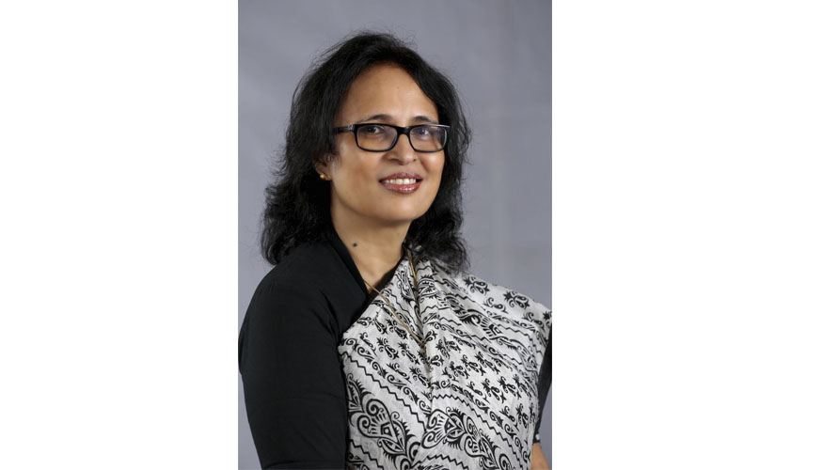

13/3/17

An alumnus of NITR, **Soma Mondal,** recently achieved a feat that has helped her etch a unique mark for herself. She graduated from the **Department of Electrical Engineering in 1984** and joined the Technical Cell of NALCO, Bhubaneshwar. She assumed the charge of **Commercial Director, NALCO in March 2014**. She has been lauded for her contributions towards devising marketing strategies for NALCO in both the domestic and overseas front. **One among few women, in a country like ours, she has risen to the top of the ladder and has been appointed as the First Woman Commer Director of SAIL, in March 2017.** She has broken gender stereotypes throughout her life and paved her way towards success in a tale filled with struggle, hard work, and patience. In an interview with Team MM on a fine Sunday Morning, she shared her remarkable journey, from being a shy girl at REC to assuming a position of such high repute.

**MM: Tell us about your life before joining REC.**

**SM:** I was born and brought up in Bhubaneswar and completed my primary education there. I appeared for my 12th Board Examinations from BJB College, Bhubaneswar. **I was brought up in a family where education was given utmost priority and no compromises, whatsoever, were entertained in this regard.** My mother looked after my day-to-day studies and despite her other engagements, ensured that my education was not hampered in the least.

**MM: In an era when women were dissuaded from pursuing education, what kind of support did you get from your family to pursue engineering?**

**SM:** My father, as all fathers do, loves me very much and was very protective of me at that time. Since he wanted me to have a hassle-free and calm environment to pursue my education, he was initially reluctant to send me to an institution that had just a glaringly skewed gender ratio. In fact, he even suggested that I pursue Medical Science or a degree in Basic Science, instead. But, it was my mother who was a pillar of strength and relentlessly supported me so that I could pursue my ambition. She explained to my father that if Engineering was my calling, then I should be allowed to chase my dream. As a broad-minded person and a liberal at a time, when they were indeed fewer in number, she believed that as her daughter I could do whatever I wanted in my life, irrespective of my gender.

**It is mandatory that I mention at this point, that my mother could not pursue a professional career, despite having the requisite skills, because of several societal and familial constraints. Thus, when it came to me, she ensured that I would not have to face a similar fate. Overall, my father has been the source of inspiration for finer aspects of my life, but my mother has been the one, undying motivation for my professional career.**

**MM: Tell us something about your life during your stay at REC. Do you have any special memories of your college days?**

**SM:** My days at REC were fun in their own way – we had a small group of 8 to 9 girls, in the college back then and we became a family for each other. **We were so closely connected that these years in between have hardly made a difference and I am elated to tell you that all of us are still in touch.** When it came to our male counterparts, the interaction can be called ordinary, since we soon came to treat them as classmates and our initial prejudices were overcome.

**Being a girl in an engineering college then was indeed a privilege as the faculty in our department, as well as in the workshop were extra protective about us. They did as they deemed fit to ensure a healthy, and fair learning experience for every single one of us. As individuals, those days were instrumental in shaping our personality and we took up the onus to look after ourselves, as well as each other. As of now, I cannot recollect any specific memory, but needless to say, there were several significant ones.**

**MM: What was the environment on campus like, back then? What kind of extra-curricular activities were you involved in?**

**SM:** The environment on campus then was certainly good and we never faced any problems. I have to mention that for a major part, the experience was noteworthy because of my batchmates, many of whom I am still in touch with. As far as extra-curricular activities are involved, we were a small group of women who were shy and hesitant to step out of our comfort zone, lest we become more prominent. It was not like we were too career-oriented or studious, but we confined ourselves to within the group. I personally also tried to involve myself in as many hostel activities as I could.

**MM: Being a graduate of the Department of Electrical Engineering, how would you compare the job opportunities then, to those available now?**

**SM:** During my time, most of the graduates preferred jobs in Public Sector Units, Central Public Sector Enterprises and some in Private Ventures like Tata Steel and LnT. So when I graduated, I only thought of these as possible career options. However, some of my friends did shift to Civil Services and some other seniors and friends took up research, which was a popular option for women, back then. Basically, for me, I always wanted to have a corporate job, irrespective of whether it was in a core or non-core discipline, since I never imagined myself in an academic setting, as a teacher.

**Today I feel happy to see that women are willing to join in various fields, be it core sector, jobs in factories, IT sector or research. Back in my days, the workplace in core sectors was also not conducive for women to work in, but today that has changed tremendously.**

**MM: How was your professional life during your initial years at NALCO? Could you brief us about some projects which you were a part of during your tenure?**

**SM:** During my initial years of career, I joined NALCO Bhubaneswar’s Technology Cell. At that time, NALCO was still in the project stage and had not been commissioned. Work was good enough and the system was very supportive of us. I looked into the technical aspects of various undergoing projects that NALCO had taken up, then.  **I was a part of the team which was working on the synchronization of the Capture Power Plant (CPP) with the grid**.

**MM: How was your experience as The Commercial Director at NALCO BBSR? What are some of the major goals you achieved under the post?**

**SM:**NALCOis a company that has grown extensively in the last couple of years, and coincidentally I have also grown with it. A position of such high repute in a large enterprise such as NALCO carries a tag which not only comes with authority but also several responsibilities. **My experience throughout my tenure was made both pleasant and enjoyable because of the bonding I shared with the company - perhaps it was because NALCO was my first job, or perhaps it was because it paved the way for me to pursue a career in the commercial field.**

My marketing responsibilities included procuring the best product at the best price, and the most challenging aspect of this job was to ensure a continuous flow of raw materials because the slightest change of quality or quantity there, could jeopardize the entire production process. We made systematic changes as we deemed fit, without altering the continuous flow of events. **As a Commercial Director along with my obvious responsibilities, I was also in charge of the marketing and procurement of goods so I needed to focus on maximization of sales and maximization of right product mix to get the maximum realization, to balance all exports in the domestic market.**

**MM: At this time, when the steel industry is facing a low demand in homes, what plans do you have in the pipeline as the new Commercial Director of SAIL?**

**SM:**One of the major tasks for the Government of India as well as SAIL is to increase the demand for steel in our country, which is being done by conducting various workshops and seminars to bring about awareness among the public.**We are focusing on the fact that cost efficiency should be based on the life of the product rather than on its cost. We are trying to educate the common masses about how steel can be used in various ways and how it is better than its competing products.**Our focus is also on retail side to increase the retail and export presence in the market, to improve the value-added tax (VAT) amount. Although the Government has been very supportive regarding the price of steel, there needs to be a proper increase in the demand of steel for proper commerciality. There are certain areas where the demand for steel is quite low and our main focus is on improving the demand in those areas.

**MM: Despite being in a core industry, where gender inequality exists, what according to you helped you in surpassing all odds and gaining the post of the first woman director in both NALCO and SAIL?**

**SM:**The first thing that I would like to mention is that I did not face any gender discrimination during my tenure of work in any of the two companies, NALCO or SAIL. Speaking genuinely, the major trouble that most women face at work is because they disbalance their time between work and family. Unless you are able to manage your home efficiently, the shortcomings at work will be inevitable.

**For those women who feel that their career growth is important, they should be able to balance the two, since their absence from home might not hamper its continuous running in a humungous way, but their absence from work, most certainly will. I was able to ensure this balance because of the support that I got from my family. They have always stood by me and I know that I have been able to surpass all odds because they were there for me. They devised their own backup plans to compensate for my absences for few days or extended periods, and I could not have done any of this without their love.**

**MM: What are some of the activities that you do for leisure?**

**SM:**Since I lead a stressful life, I try to avoid involvement in anything serious. I mostly spend my time watching the news and a few comedy soaps, which are light-hearted and can be enjoyed in the moment. I also like to keep in touch and communicate with my kith and kin, so as to have a peace of mind with regard to their whereabouts. Frankly speaking, I do not have any hobbies as such.

**MM: What is your take on the role of alumni for an institute of national importance like ours? How do you think the present scenario of alumni interaction can be improved?**

**SM:**In my opinion, for any student who is pursuing his/her degree from a reputed institution like ours, the ultimate aim is to make a place for themselves in a field of their choice. In this aspect, I think alumni interaction can be vital on two fronts. Firstly, the alumni who have assumed positions of importance in respectable companies can come forward at the time of placements to increase interest in our institution as well as to provide opportunities in terms of internships or placements, to the current students. Secondy, a direct interaction will be helpful to those who have queries or require guidance in any form. Thus, I think guest lectures should be organized more frequently, and the current students should make it a point to attend them.

**MM: What are some of the most significant changes you have observed in the institute and what further changes would you like to suggest?**

**SM:**I have been to the institute twice in the last two years and I can see that the female strength of students has been increased to almost 40 percent. Moreover, I believe a lot of new branches have come up over the years and though I am not aware of the exact academic curriculum but I think more focus should be given on developing the entrepreneurship skills of students. I was elated to hear that students in their sophomore year have been coming up with their own start-ups. I am impressed with the way our institute is running and I do not want to comment on the lackings as I am not aware of the present statistics. Finally, I hope to see more and more individuals coming out of this institute who are professionally excellent and humanitarian in their own way, as well.

**MM: Any message that you would like to give to our readers?**

**SM: I am proud to be a student from NIT Rourkela and I hope that one day when you graduate, you feel the same too. Always give your best in whatever endevour you take up. Do not crave for short-cuts either in your professional or personal life as there are no short-cuts in life. The ones that bring you momentary gains affect you adversely in the long run, and thus there is no point in seeking them. Work with passion and both acknowledgment as well as growth will come as a consequence. Do have a hobby, which I unfortunately missed out on, because it helps you a lot in times of stress. Always remember your professional aspirations and personal goals should be properly aligned as both are equally important.**

16.

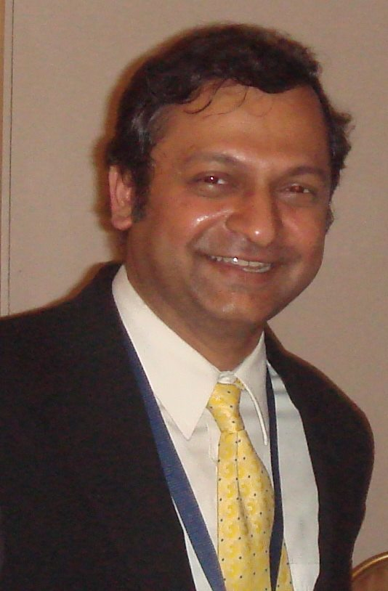

25/2/17

Dear NITRAAN,

Greetings.

You would be happy to learn that Sri Ashutosh Dutta, one of our alumni from 1985 batch, has been selected as Distinguished Lecturer by IEEE Communications Society for the year 2017 and 2018.

<http://www.comsoc.org/> distinguished-lecturer/ distinguished-lecturer- ashutosh-dutta

As part of this opportunity, he is scheduled to travel to different parts of the globe as an ambassador for IEEE Communications Society and give technical talks to Academia, Industry and Regulators.

He will be visiting India and give his Distinguished Lecture Talks in 8 cities between March 14 and March 24, 2017. These cities include, Mumbai, Hyderabad, Kolkata, Bangalore, Chennai, Trivandrum, Jaipur, and Delhi.

We are including his tour and talk details. If you represent any of the above mentioned Chapters, or happen to be there in any of the cities during this period, you can meet him and attend his talk in those cities.

His talk title is "Security Challenges and Opportunities in SDN/NFV and 5G Networks and bio" and his contact details are furnished below for your kind information please.

Ashutosh Dutta, Ph.D.  
AT&T, New Jersey  
IEEE Communications Society Distinguished Lecturer  
Director Industry Outreach - IEEE Communications Society  
IEEE 5G Initiative Co-Lead  
[www.ashutoshdutta.org](https://l.facebook.com/l.php?u=http%3A%2F%2Fwww.ashutoshdutta.org%2F&h=ATOzFbSOrlDVFh5ippQsjkraVt4B0Z61Fkis4PyIDQNTniqORPKsS85PvnT8DCGweGBHqWT_K0RBvBfGEaMmyaAl7qe4Ncne4wB3UavvwwXG7kR68CmddpqU9PYqynLzFmEORpA89A-zeTlN4Dx5ieTbDwU5kAMwQqYtVekSuOxCZalJaSIVyZdMZfDo403HnsCJPz94RewvjFnXe9RffJQya3WIyt00NazobMr-P3EKyrDLah9Ge7zBYJjVYg6nYyxHIXwxSE1sFzegn12La96n)

[Ashutosh Dutta](https://www.facebook.com/ashutosh.dutta.5?fref=mentions) [IEEE Xplore](https://www.facebook.com/IEEEXploreDigitalLibrary/?fref=mentions) [Leo Kurians Paulose](https://www.facebook.com/leo.k.paulose?fref=mentions) [Anup Agarwal](https://www.facebook.com/anupagarwal91?fref=mentions) [Nit Rourkela Nitraa](https://www.facebook.com/nitraa.gs?fref=mentions) [#NITRAA](https://www.facebook.com/hashtag/nitraa?source=feed_text&story_id=985731701561782)

17.ferveror with dynamism: Dushyant Mishra

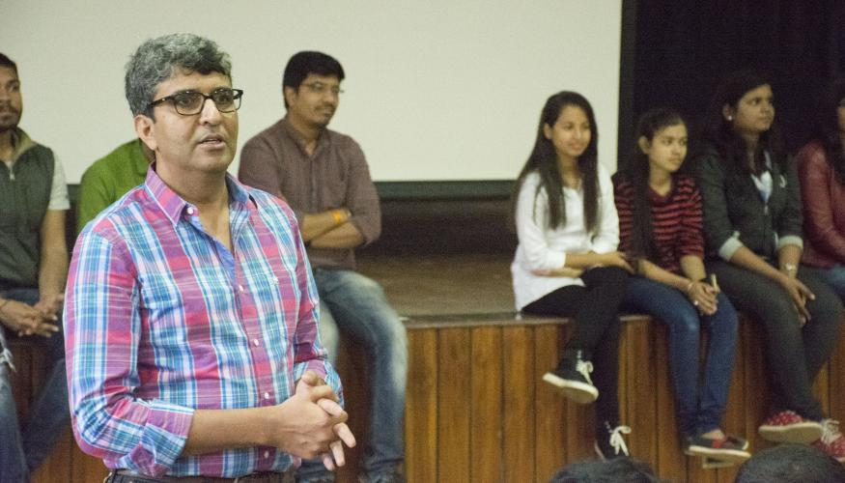

23/1/17

Alumni form a core factor for any leading institute. Having a widespread alumni network not only etches a mark of the institute, but also helps in improvising the various aspects of the institute. **Mr. Dushyant Mishra**, an alumnus of REC, Rourkela is a man with a vibrant personality who just does not want anyone to call him 'Sir'. **He graduated in 1996 from Metallurgical Engineering and currently is the co-founder of Xtory.** He visited the institute on 18th January to have an interaction with the students. So, on a chilly night at Hexagon Restaurant, he shared with Team MM about his various stages of struggles and what kept him moving on towards success.

**MM: What is a highlight of your school experience? Is there something that will stand out, which you will always remember?**

**DM:** My father had a transferable job in Rajasthan State Government and hence I got to study in multiple schools. I studied in Convent schools as well as Government schools. Every school, there are two things that I remember distinctly. One, I got some wonderful friends with whom I am connected till date. Second, I even remember some teachers, who helped me in gaining my interests. These are some of the experiences which I would cherish.

**MM: Describe your life at REC.**

**DM:** REC days were awesome. Those 4 years were the best years of my life. I did everything but studies *(laughs).*  I made a lot of friends over here, met some wonderful people who helped me in becoming what I have become today. I learnt speaking English over here.

I used to participate in various extra-curricular activities. We didn’t have clubs back then and there existed an open concept, where one could do anything and no one could stop you. I discovered that I could conduct quizzes and hence conducted a lot of quizzes. I used to watch a lot of movies, as we had movie screenings in now-BBA. **I dreamed a lot over here. This place inspired me a lot. Its sheer vastness made me realise my potential and do something big in my life.**

**MM: Have you ever tried something and failed, but were glad that you did it? What did you learn from your experience?**

**DM:**

**I have no regrets in life. Every time I took any decision that was the best thing of that day. The results did not matter, because result is something that happens in future. That point whatever I decided, that was the best that I could do. I do not look back in life in that sense.**

**MM: Share something about your early startups.**

**DM:** I wanted to start something in training, but then I realised that it is much fluttered. Then I had a passion in travel and I started curetting vacations for people. But I could not productize it and a startup which cannot be productized is no startup. Then **Sportspasta** happened. My friend, Manish and I came together and worked hard on it for two and a half years. We got a fantastic social response and everyone who was a stakeholder appreciated it, except the investors. Since a business has to run on money, that’s when we had to take a call and close this down. It was like killing your own child. But I learnt a lot from that experience.

**MM: Tell us about startup culture during your college days. When did you finally get to be associated seriously with them?**

**DM:** We had an entrepreneurship cell at the second floor of Main Building. But none of us knew even how to pronounce the term. So that was what the startup culture was during my college days. Nobody bothered to visit the cell. The word startup did not exist then.

During those days the economic conditions were different with first results being shown, Y2K problem emerging and that’s when the Indian IT sector boomed. But I just continued my work.

**MM: What was the main motive behind identifying your identity in the field of Life Insurances such as Bharti Axa and ICICI Prudential? How was your overall experience in the financial sector?**

**DM:**I was working at a technical post at a PSU. Life has funny plans for people and I went through that. I quit my job and was to join Ramco Systems, but due to some personal problems could not do so. Then I joined another technical company and walked out of it after 90 days. When I reached home that day, I discovered that a consultant was trying to reach me for the post in Sales at ICICI Prudential. I was hired and then it was a dream run over there. I had finest years over here after REC. Then I worked in some other insurance companies and found cultural mismatch over there.

**From this, I want to say that every company has its own distinct culture and you have to find that company which matches with your DNA, because only then you will enjoy your work.**

**MM: You have a keen interest in travelling as you have travelled over 800 villages. How would you link this with your personal and professional life?**

**DM:** **I believe that we do not have any split personality. I do not have any such things as personal life and professional life.**Whenever I travel either for work or solo or with my daughter, I always learn because travel puts you in circumstances which are unpredictable. You are always your guard and hence you learn more. During my days in ICICI, I travelled a lot and I was lucky that my work wanted me to travel and I had a passion in that also. **So I would say that my work helped me in travel and travel helped me in work.**

**MM: You have been a co-founder at Sportspasta. Please give us an insight about the organisation and your aspirations behind it.**

**DM:**Sportspasta happened when my elder daughter wanted to learn chess and she started learning from a coach who used to come to the building. One day I overlooked the class and found some mismatch in it. I decided that I do not want this for her and hence I started searching a better coach for her. The next 8 months were spent on finding a coach and while searching for the domain of sports on the internet, I realised that there is a white space in it. So I talked with Manish and we spent many months on exactly what customers need. **The model was that we would help people showcase their talent such that they would get the opportunities. So Sportspasta would have worked on a platform where talent meets opportunity**. This was the basic idea.

**MM: Tell us about your current career experience as co-founder at Xtory. How did this idea surge and take a serious stand in your life?**

**DM:** I travel a lot, particularly road trips and I travel with my daughters. I tell them stories about places like its culture, vegetation, people etc. But at times I fail to answer some of their questions and Google would also fail to answer them. **We used GPS to travel and then I realised that why GPS cannot tell us stories about the places that we were visiting. This was the genesis of the entire concept.**

I got the technical feasibility done. **Xtory tells you audio stories on the map. It lets you experience the place and it breaks the language barrier as the audio can be heard in any language.**Hence one can get comfortable in hearing the stories in his own mother tongue.

**MM: As an alumnus of the institute, what changes would you like to see in the institute’s administration and among the NITR youth?**

**DM:** I basically want two things to be changed over here and that is related to the students. The two things are related to the way the students live over here. **First, the culture of calling someone Sir and Madam should go away from the campus.** It creates a barrier amongst various batches and hence hinders one in having a proper interaction. So this practice should be removed so that one can have a proper interaction and it also feels good when one is called by his name only.

**Second, the students need to believe that they are problem solvers.** There were far many problems during our days, but we never saw them as problems because we believed ourselves to be problem solvers. Once you start thinking like this, then you should reach out to an alumnus. There is a lack of stories in the campus. Premier institutes like MIT, Harvard did not become famous only for academics but also for its stories. Similarly, we carry a 51 year legacy of stories and once the students start sharing stories, the entire world would know about it and this place would become more wonderful.

**MM: What are your future plans?**

**DM:** I have a bucket list of plans. With every opportunity, I try to pick them up and fulfil. There are so many things which would become hard to jot down. It is these things which keep one moving and never let him feel low in life.

**MM: What message and words of inspiration would you like to give to our fervent readers?**

**DM:**

**Believe in yourself. You are some of the brightest minds the country has got. I find the lack of believe among the students now. I would want you to believe in yourself, because if you do not then no one else would believe in you too.**

18.

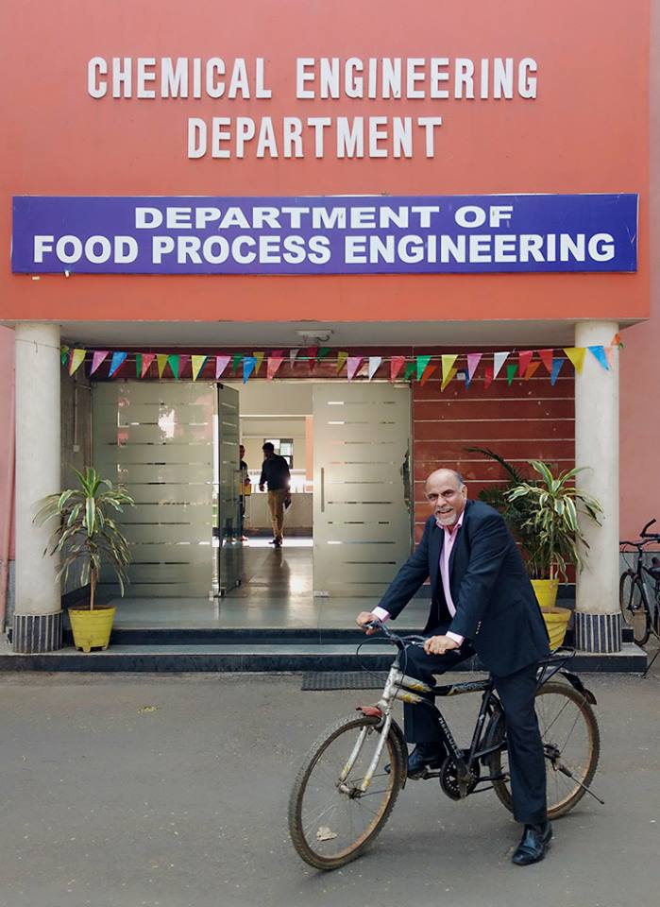

21/1/17

ALUMNUS OF THE WEEK:

This week's Rockstar on Campus is a 1986 batch Alumnus of Chemical Engineering- Lalit Vashishta.   
He is currently the MD of Diva Envitec, and his core interests lie in the filteration part of the process operation.

He had visited the campus and interacted with the current NITR Junta (students), the Deans and the Director, on the 18th and 19th of January.  
Among the many other inspirational ideas that he carried with himself, he encouraged people to stick to core chemical engineering, gave a seminar on Filteration, and talked about the scope of Chemical Engineering in the present and its sure shot growth in the future. The highlight of his visit would definitely be the brainstorming and motivational session he had with the current Placement Committee and the aspiring candidates who wish to be a part of it the next year. He took time off his busy schedule to address the budding entrepreneurs and tell them what exactly they have to do to taste success.

He is famous among his peers as a wonderful singer, plays the mouth organ, and even joked about attending alumni-singing competitions on campus https://static.xx.fbcdn.net/images/emoji.php/v9/fd2/1/16/1f604.png😄  
On being asked if he could walk up to the 3rd floor, he said, "arey 3rd kya 6th tak chalwao!" https://static.xx.fbcdn.net/images/emoji.php/v9/fd2/1/16/1f604.png😄  
In the 2 days of his stay in the campus, he has made his energy contagious! Innumerable stories shared and thoughts discussed... NITR, our alma mater looks forward to meeting this Dynamic Personality time and again!   
Kudos to him, and to NITRAA!

[#NITRAA](https://www.facebook.com/hashtag/nitraa?source=feed_text&story_id=961085954026357) [#CampusVisits](https://www.facebook.com/hashtag/campusvisits?source=feed_text&story_id=961085954026357)

19.

A sojourn to alma mater

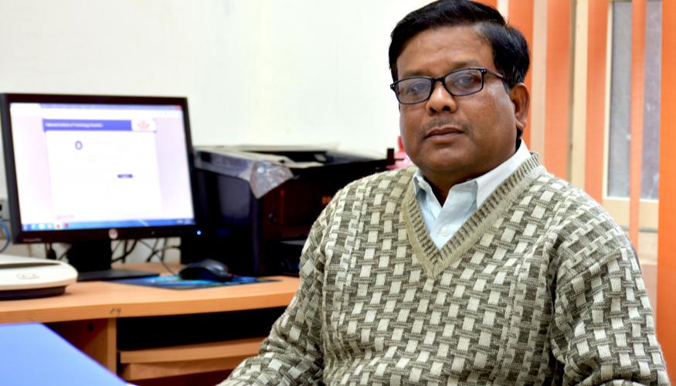

16/1/17

For any leading institute, a staunch alumni network is one of the core factors. Alumni not only etch a mark of the Institute on the geographical map of the world but also help in running of the institute on various fronts. They act as guides to the current students to help them in choosing the right career paths. Amongst the recent dissentient among the NITR junta regarding the current student-alumni relations, Team MM interviewed **Prof. Bidyadhar Subudhi, Dean Alumni Relations**on Saturday evening to know his perspective on the issue and what steps has he taken or planning to take to improvise the situation.

**MM: Comment on the current student-alumni and institute-alumni relations.**

**BS:** Both the relationships have enhanced. As compared to the previous years, alumni have now clearly expressed a wish to help out and be a part of the everyday proceedings of the Institute. **In the recent reunion of the class of 1972, the batch representative Dr Devendra Kumar Das expressed his own and his batch mates’ desire to help out the bright students who are held back by their families’ poor financial background**. There was a proposal of **an “endowment scholarship’ worth INR 50 lakhs**which would be generated by the batch. This proposal was forwarded to the Senate, and an account was opened.

**“The last I checked, the account contained almost 30lakhs and I am very hopeful of it reaching INR 50 lakhs soon. This noble gesture will certainly help out 7-8 students every year with almost 50,000 rupees.”**

The selection procedure for this scholarship will be done by a committee comprising of Dean of Alumni Relations, Dean Academics, an alumnus faculty, Assistant Registrar of Training and Placement, President NITRAA and Dr Devendra Kumar Das himself. **The scholarship will be available from July 2017, and the selection criteria will be the merit along with financial earning of parents.**

**MM: What steps have been taken by you as Dean AR to improvise the situations?**

**BS:** During the Hyderabad meet, the authorities present from our institute expressed how the MHRD’s funding is insufficient on the development work going on. So, the proposal of a corpus fund worth INR 26 crores was put forward.

Another step was that to increase the student outreach regarding indoor stadiums like squash courts, artificial mountaineering, etc., we estimated the cost to be INR 26 crores and hence we presented the idea to the alumni and urged them for their support.

**MM: Till now there is no official student-alumni relation cell. What is your say on that?**

**BS:** Last year we created a group consisting of faculty to support us. We are in the process of inducting some student volunteers now.

**“Through Monday Morning I wish to pass on the message to the student populace that the interested students are welcome to be a part of this volunteer group. We also have plans of giving this group their own work space along with telephone facility and access to the database to contact the alumni.”**

We are aiming to get one volunteer from each course of each department. It amounts to approximately 50 people.

**MM: What is your stand on the Student-Alumni Relations Cell by NITRAA and how far do you think would it help in strengthening the current scenario?**

**BS:** Of course this step will assist in strengthening the alumni-student relations better. Nonetheless, we urge you to not to confuse the working of this student group with the student group by the alumni relation cell. However, the SARC students are welcome to join as student volunteers that we require because their experience till now will benefit the cell.

**MM: The Alumni Meet which was organised last year by the Institute alumni cell witnessed a minimal participation from the alumni side. What was the cause for this and what steps have been taken by you to prevent such in the nearby future?**

**BS:** I feel that despite the minimal participation, there was a silver lining. The reunions conducted till now have been personal events where the alumni-institute interaction is minimal. **It was decided that four reunions will be celebrated, 50 years, 40 years, 25 years and ten years**. **Also, the reunions will now be conducted jointly by the Institute and alumni network and we shall be giving the necessary infrastructural support.** The reunions of the ’91 and ’72 batch were done in the similar fashion. Following the celebrations, the alumni’s are coming forward to discuss the possible way of helping out the Institute.

**MM: How did the 1972 Golden Jubilee Meet go and what were some of the suggestions put forth in it?**

**BS:** In addition to the handing over of endowment scholarship check, we proposed the idea of “**chair professor**.” There are essentially two kinds of chair professors; we introduced the idea of one who is entirely funded by the alumni network. An existing professor could also qualify for the same and get an additional bonus from the same. **This proposal will encourage research and quality work.**

**MM: In an interview with distinguished IPS officer Lalit Das, he suggested to have an app showing the addresses and contact numbers of all the NITR students in the nearby location. What do you think about its feasibility?**

**BS:** This is a good idea certainly, however, the frequency of the usage of the app is also essential**. The database of the oversea alumni needs to be improved, and we lack the human resources of the same.** Comparison with other institutes is fruitless as they have the required workforce and we don’t.  Preparation of the app is a technical and simple task. The major challenge is the maintenance of the database.

**“We have requested for a full-time employee for the maintenance and management of database.”**

**MM: What was the outcome of the recent alumni meet in Hyderabad and how do you plan to implement them?**

**BS:** The first result of the event was **to make the alumni database more pragmatic and updated**. Also, considering how most of our alumni are heading various MNCs, many deliberations were held **on steps to be taken by both the Institute and the NITRAA to enhance the placement scenario.**Additionally, in the presence of various authorities, we chalked out changes to be made in the curriculum keeping in mind the inputs from the alumni. **To increase the employability and skills in students we are in the process of making a document that will be circulated among the alumni network and feedback will be recorded on the academics. These feedbacks will be inculcated in the curriculum change.**Plans were drawn out to strengthen the School of Management of our institute with the help of Vinod Gupta School of Management. **A student-alumni interface cell was another suggestion, but it requires the student participation.** In the following years, more alumni will be visiting the institute and giving talks.

**In a nutshell, we are in the process of making such changes that will allow the alumni to contribute to decision making, fundraising and mobilising the student's interest in internships, etc.**

**“Also, we would like to inform all the students that in the past six months, the website of alumni relations has been revamped and updated. All students are requested to make full use of this.”**

**MM: There are plans of various alumni’s visiting our institute in the coming weeks which was decided in the Hyderabad meet. What all arrangements have been made for the same?**

**BS: Mr Venkata Narasimha Peri is due to visit on the 21st of January**. However, the exact schedule is not finalised yet.

**MM: Do you plan to have events like this every year?**

**BS:** Yes there are ideas in the pipeline of such kinds of meet almost two times a year.

20.

# Support To Create A Memorial For Siladitya At NIT Rourkela

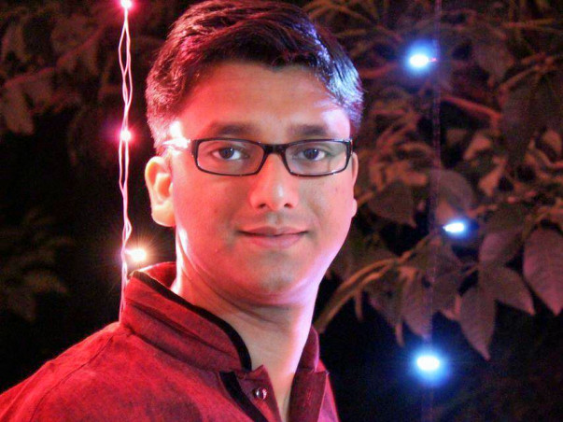

15/1/17

All of us are just around the milestone of 30 years. 30 is when we run the fastest in our life race. We get married, plan families, build our career. There’s no room to pause. It’s as if life is certain and we are in control.

A car, an unfortunate accident, a fatal collision, 40 days of struggle and finally Siladitya (Silu) called it quits. We are sure he didn’t want to. ([Click here to know more](http://timesofindia.indiatimes.com/city/pune/Speeding-car-jumps-median-on-expressway-two-injured/articleshow/54687129.cms))

God or Fate - whatever we choose to call it is ironic! On one hand, it gives us 4 amazing years of our life where every one of us got a second family. On the other hand, it takes a family member far far away.

Good or bad, life moves on. But here I plead, let's stop being busy for a minute, rewind our lives and remember the amazing time we had. Think of those with whom we laughed, we cried, we fought, we danced and realized they were never just friends but more than that.

Silu was a good guy, probably the one who taught us what being good meant. Let’s keep him in the race. Let him be a reminder that each one of us owes a part of our lives to those 4 years and the people who shared it with us.

We have planned to start a memorial award for Silu at NIT Rourkela. With due consultation with Dr. Subudhi, Dean of Alumni relations at NIT Rourkela, there will be an annual award given out (The details of the award would be figured out soon based on the total amount raised). Let’s all pitch in.

Salute, To those 4 years. To Siladitya.

Siladtiya Pattanaik

BTech,Electrical Engg 2008

1986-2016

**Award rules and Guidelines:**  
The principal amount goes to a Fixed Deposit and annual interest amount is given as an yearly award. The award amount is usually fixed. If the annual interest amount is less than the award, the remaining is deducted from the principal or requested from the person/group created the award.  
  
The objective of the award to remember Siladitya by helping out a student currently needs of financial assistance for curricular/extra curricular activities. Thus it should not be limited to academic excellence and could be achieved by any student at our alma mater. The detailed category and award amount depends on the total amount raised.  
  
If you would like to share a eulogy, please share it in the comments section.